go

By Mustafa Jaffar

Table of Contents

1.0 Analysis 3

1.1 Identification 3

1.1.1 Why this is solvable by a computational approach 3

1.2 Stakeholders 6

1.2.1 End Users 6

1.2.2 Requirements 7

1.3 Research 8

1.3.1 online-go.com 8

1.3.2 Go by AI Factory Limited 11

1.3.3 BadukPop – GO by CorePlane Inc. 13

1.4 Essential features and limitations of my solution 16

1.4.1 initial concept of the solution considering the research 16

1.4.2 Limitations of my solution 16

1.4.3 Success Criteria 17

2.0 Design 19

2.1 Decomposition 19

2.1.1 Main Menu 19

2.1.2 Gameboard 27

2.2 usability 33

2.2.1 Main Menu 33

2.2.2 The Account Page 40

2.2.3 New Game Page 43

2.2.4 Load Game Page 46

2.2.5 The Game Board 47

2.3 Algorithms 50

2.3.1 Finding a valid position to place a stone 50

2.3.2 The main menu 53

2.3.3 Calculating Elo Rating 54

2.3.4 The Result of the Game 55

2.3.5 New Game 55

2.4 Classes and Data Structures 57

User 57

Game 58

2.5 testing 58

3 Development 58

3.2 Prototype 1 58

3.3 Prototype 2 58

3.3 Prototype 3 58

# Analysis

## Identification

Go is a board game which is said to be one of the oldest board games as it was created nearly 4000 years ago in China. It is popular in China, Korea and especially in Japan. Japan had 4 very competitive go schools which was set up and funded by the government during the Tokugawa, which made Go a profession in Japan. It later became globally popular in other countries after World War 2. There is also a European Go federation which holds many different competitions and championships in several countries every year.

Go is a 2-player abstract strategy board game where the opponent is trying to capture territories on the board by encapsulating the territory with their pieces, also known as stones. The two plyers get assigned a colour at the start and usually the weaker opponent gets white, at a turn you can either place a stone down or pass a stone to your opponent to ‘surrender’ your go. You win by capturing the most territories on the board, where one territory is an intersection between lines on the playing board.

I have spotted that not many people enjoy playing Go or have the physical board game at hand so that I will be solving this issue. I will be creating an online version of Go that will allow multiple users from the same network to play the game. They will be able to choose their difficulty level and get a randomly selected person at the same difficulty level to play with them. This should allow players from all backgrounds to play my game.

### Why this is solvable by a computational approach

This is solvable by a computational approach as I can discretely compute all the necessary outputs required for the game to run properly as I will explain now.

Finding captured territory can be thought of like a graph, where each node is a stone and each edge is a connecting chain of stones, so I must find a loop of same-coloured stones for a capture, a cycle. Cycle detection is a classic computer theory problem which can be applied to this game. This takes a finite amount of time and due to the nature of the game, regardless of how the game is played, the algorithm I will develop will always be able to compute the required output, like to see if a valid move can be played, within an acceptable time frame for the user regardless of their level of skill. I can use algorithms such as union find to detect any cycles within the current game state.

The game can also span many hours at the highest skill levels, so allowing them to save and store games on the computer, in memory, and easily restore them can be solved using computer hardware such as an HDD. Instead of needing to play the full game to completion, I can use the computer to be able to store and save game states so the players can come back to it later when they have more free time at hand.

Another reason is that they may not have the board and pieces available to them all the time or have enough people to play with. To overcome this, having an online version allows you to be able to play on demand and to know there might be other people wanting to play with you rather than physically. The computer can guarantee you the board will always be exact and that, assuming other users are on the game, another player will want to actively play the game with you.

Keeping track of rankings can be tedious and has a lot of room for error. We can reduce this by using the computer to do all the math for calculating the Elo rating for us. An Elo rating is a number given to all players which indicates their relative skill level against all other users who play the game, I will explain this in detail later. I would store the ratings and the game on the same app as it puts less memory strain on the user.

#### 1.1.1.1 The Elo Rating

The Elo rating is a way to rank order all the existing players within a zero-sum game. It allows us to easily compare the ability of any two players and their relative skill compared to everyone who plays the game. In Go, for certain Elo ratings there are associated ranks, the Kyu and Dan ranks.

I will initially discuss the expected value of the players. The expected value is the probability of the player winning their match. This is calculated by using the formula shown below.

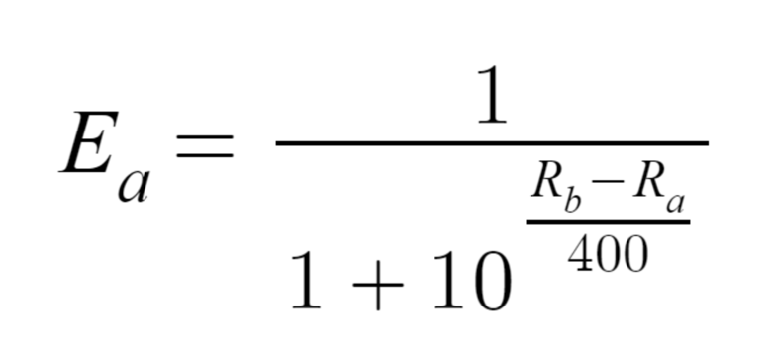

Here, Ea is the expected value of player A. Ra and Rb are the current ratings of player A and player B respectively. The constant 400 is the scale, its used to define the spread of the ratings, how sensitive the change in ratings are. The larger the scale the larger the spread of ratings. I will use 400 as it makes the ratings more intuitive to understand.

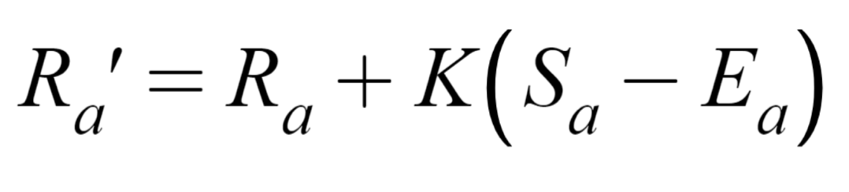This is used to calculate the new rating for the user. Ra’ is the new rating, Ra is the current rating, K factor and the score S. The K factor puts a cap on how much you can gain or loss points on your score. More skilled players have a lower K factor as they have a higher confidence level because they are more consistent in their games.

#### 1.1.1.2 How The K factor impacts the new rating

The k factor in the elo rating puts a cap on how many points a player can gain or lose from a single game. This is multiplied with the game score, a binary 1 for a win or 0 for a loss, minus the probability of the player winning the game.

The k factor should be lowered as the player gets a higher rating as their playing becomes more consistent and less random. Usually, 32 is used for weaker players while 16 is used for stronger more experienced players.

Here I have two players, one novice rated 700 and an expert rated at 1500. Both have a probability of 0.75 for winning their game and have won it. Even though both players have the same game state and outcome, their rating increase differ.

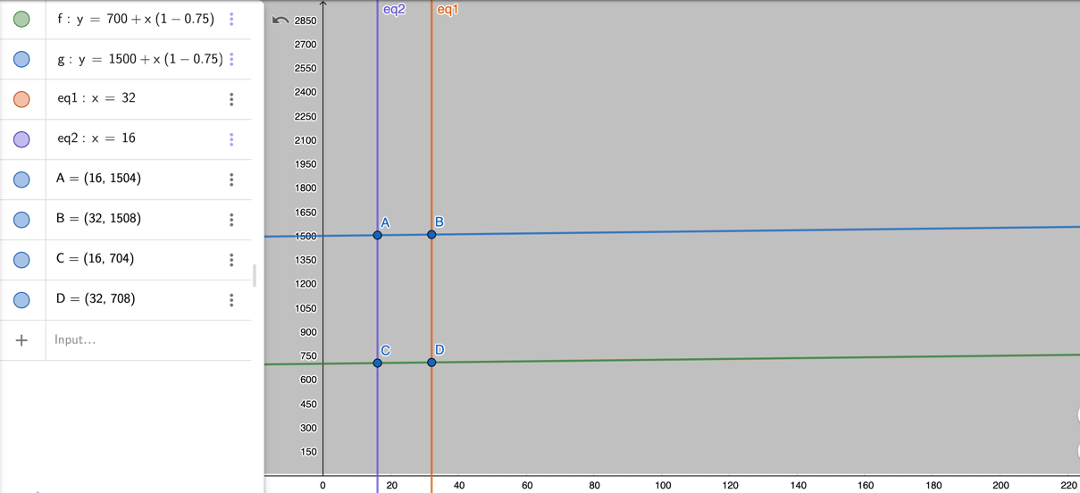

Figure 1 graph with k factors of 32 and 16

The 1500 rated player will get the new rating of 1504, while the less experienced player will get a new rating of 708. If the experienced player were to gain an extra 8 points, having a K factor of 32, this would inflate his rating very quickly and make his rating less valuable. This would mean he has the same variability and the same point trajectory as the less experienced player, which is incorrect.

## Stakeholders

### 1.2.1 End Users

Players with little or no knowledge of the game will be able to select the board size of 9x9. They can play a simple game to start off with as they can learn how to play the game and begin to understand the rules. They will be matched with someone at the same skill level as them so they can reasonably advance within the game.

Intermediate players with be able to choose a board size that is either 13x13 or 17x17 to be able to play a more stimulating and challenging game as there are more possibilities and combinations that allow for a wider variation of the game. They will need a more advanced level of play for them to enjoy the game.

For the most skilled players they can play with an indefinite range of board sizes, the game will have a max of 20x20, as they can and will enjoy playing the game, which is the which should satisfy their needs and allow them to play a challenging enough game for them. They will most probably play for hours so the ability to save the game state is a needed requirement.

Another more general stakeholder is the casual player of Go; this is where they may not have the board and pieces available to them all the time or have enough people to play with. To overcome this, having an online version allows you to play on demand and to know there might be a lot more people wanting to play with you.

|  |  |  |
| --- | --- | --- |
| The user | Interaction | Availability |
| Novice | * Smaller sized 9x9 boards for games * Using the online feature to find other players at same level * Maybe 10x10 boards for advancement | * often |
| Intermediate player | * Medium sized boards for games * Playing games of about an hour or more * Tries to advance by using larger boards | * often |
| Advanced players | * larger sized boards tot their choosing up to 20x20 * they will play for long period, such as 2-3 hours or more * ability to pause and save a game state * maybe play smaller boards for shorter amount of time such as 30 mins | * very often |

### 1.2.2 Requirements

#### 1.2.2.1 Software

|  |  |
| --- | --- |
| **Requirement** | **Justification** |
| Windows 10 | Allows the user to access and play the game |
| Python 3 downloaded | Allows the user to download and run the game |
| Mysql connector | To access the global leader board |
| Random.randint library | To be able to randomly select player 1 and player 2 |
|  |  |

#### 1.2.2.2 Hardware requirements for my program

|  |  |
| --- | --- |
| **Requirement** | **Justification** |
| Keyboard | To be able to input your username |
| Speakers | To play the background music |
| 5 MG of HD space | Minimum requirement to store the game with its data, such as the images, sound and storing JSON files |
| Monitor | to project the software onto a visible media |
| mouse | To control the stones and navigate through the game |

#### 1.2.2.3 Requirements to run python

|  |  |
| --- | --- |
| **Requirement** | **Justification** |
| Mac OS X 10.11 or higher | So the operating system can maintain and run python |
| Python 3 | To be able to run python |
| 4 GB RAM | To hold the current processing of python |
| 5 GB free disk space |  |
| Monitor | To be able to see python visually |
| mouse | To be able to click and select download and edit in python |
| keyboard | to be able to search for python, to type python |
| Processor | To be able to run python on the computer |

information from <https://support.enthought.com/hc/en-us/articles/204273874->Enthought-Python-Minimum-Hardware-Requirements

## Research

### 1.3.1 online-go.com

online-go.com have a wide variety of services that include puzzles, learning the fundamentals of the game, many tournaments, multiple forums to discuss the game and much more. The main feature is the online playing of Go, where you can play against other people with roughly the same rank as you to play against. They also have a joseki, which is a hotseat version which analyses the game as you play each other telling you whether you played a good or bad move.

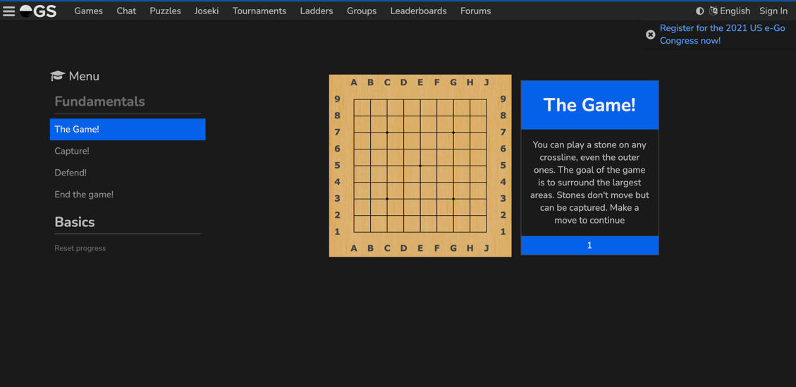

Figure 2 this is the main menu and the fundamentals page

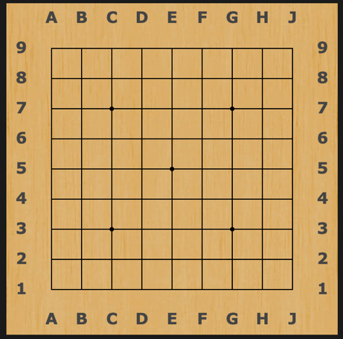

Figure 3 this is the wooden board style

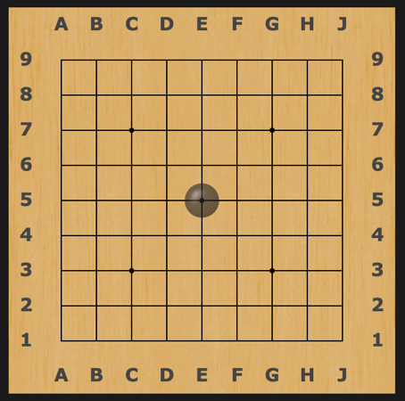

Figure 4 the automatic stone placement

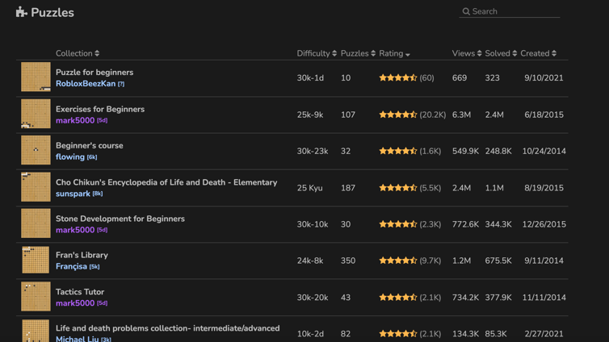

Figure 5 this is thier puzzles menu

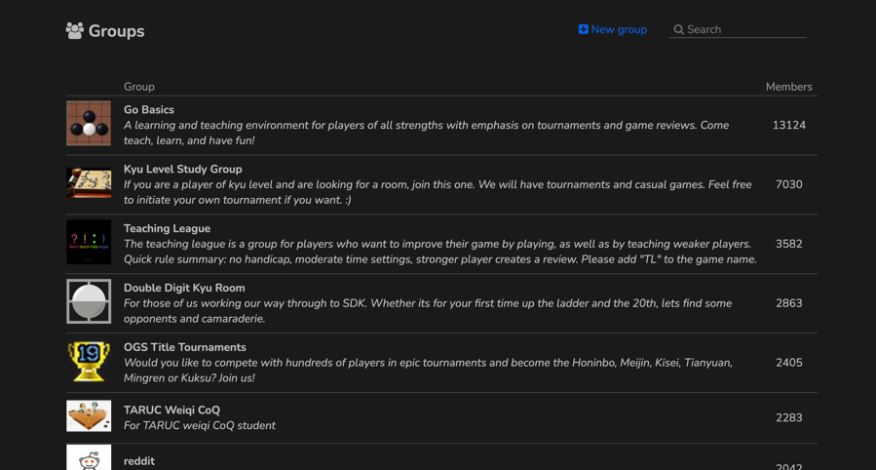

Figure 6 the groups page for online-go.com

Pros:

* I think their user interface for the main menu is excellent, its very clear and has very few options for quick and easy recognition of what is available (fig 3)
* Having a puzzles section works well as it lets new players learn tricks for playing the game before they start playing against ither people (fig4)
* They have practice puzzles and a fundamentals section in their app which I think would be very valuable to add to my game, however it is out of the scope of the project as it would take too long to think of and design puzzles.
* They have a group section in their game. This lets users form and compete against other groups.

Limitations:

* They have a menu section in the left-hand side of the screen which would potentially distract the user while playing (fig 1)
* For novices new to the game, their ratings for the difficulty of the problems will be hard for them to interpret (fig 4)

Features I may include:

* Their imitation of the real life go board is a useful feature to add as it immerses the user into the game, I think this will go into the final solution (fig 2)
* They have a menu section in the left-hand side of the screen
* Their board puts in automatic shadow stones put in for you when you are over the different positions, I think I will include this as it makes using the game easier, it increases usability (fig 3)

### 1.3.2 Go by AI Factory Limited

Go is an online downloadable android phone app that allows you to play against its AI Go player or has a hotseat option to play with other friends you currently have around you. It offers the chance for you to play the AI at multiple different difficulties and lets you choose what board size you want to play on (9, 13, 17 or 19). It has the very useful setting that allows you to edit the white handicap so you can play harder versions of the AI or play a more skilful friend in the hot seat section.

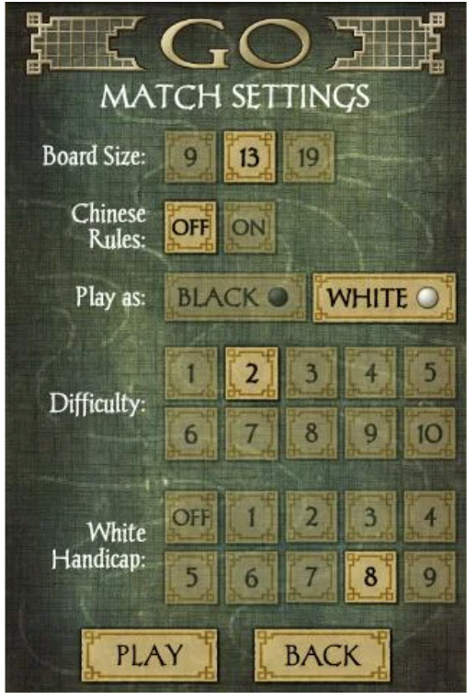

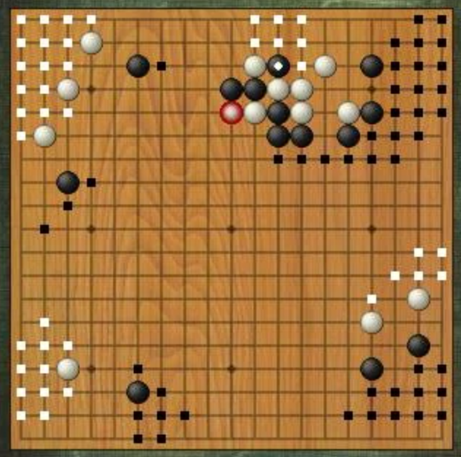

Figure 7 here is their wooden board

Figure 8 the settings page

Pros:

* Having an AI is an excellent feature as it would guarantee users the ability to play the game regardless of their internet connection or if they can’t find other players in real life to play with
* Their board is modelling a wooden go board, imitating the real-life original version of Go, I think I will follow this design as it would make the game feel more realistic for the user. This will greatly benefit my solution (fig 5)
* It allows you to change the different factors of the game, such as the board size, Chinese/Japanese rules, the difficulty of the AI and what handicap white should have, in a setting menu (fig 6)
* It keeps the number of stones captured by the opposition in brackets by their username
* It also has a two-player hot seat option
* It gives you hints when you get to the higher levels, such as Dan 1. This is a pro as it will guide players to try and get to the higher level of play without it being too intimidating

Limitations:

* It doesn’t allow you to randomise your starting colour. This isn’t good as it wouldn’t allow the user to have the chance to play as the second player. This would not meet the needs of the end user as they would want to experience the game from both angles. This would not be a suitable feature for my solution.
* You cannot play online against others, only hot seat or against an AI. This would not meet the needs of my end users as being able to play others while not having anyone physically near you is the key idea behind my solution. They would not be able to play whenever they want against another human.
* They do not offer the ability to save the current game, this would not be suitable as a single game of go could last a couple hours. This wouldn’t satisfy the needs of my users might not have the time block of a couple of hours in a day to play a full game of go. Saving the game state is needed in my solution as my targeted userbase includes advanced players which will play for long hours which they may not have in one sitting

Features I may include:

* It has an AI which you can play against if you are offline, this is beyond the scope of my solution however it will be something I can potentially work on in the work on in the future.

### 1.3.3 BadukPop – GO by CorePlane Inc.

This is an android mobile app that allows you to play games against others online at any time. It also has features such as practice problems to be able to sharpen your skills at go, what they call tsumego, while completing the problems you can also collect keys that you can use to see how far you have advanced through the game, so the more keys you gain, the longer you have been playing the game for. They also allow you to rank yourself against other players with a global leader board. You can play against an AI with a variety of different difficulty levels which allows for multiple users.

Figure 8 a view of one of thier practice problems

Figure 9 the study room page showing multiple problems you can solve

Figure 10 thier board layout with two active users

Pros:

* It has a range of avatars you can choose from to be your icon when playing against other users, lets the user personalise their game
* It has an AI that allows users to play offline when they aren’t connected to the internet, so they will always be able to play regardless of internet connection
* It allows you to add friends and has a personal leader board to compete against your friends
* It has an ‘Automatch’ feature which matches you to another player with similar skill level to you to play against
* They show the relative rank of the person next to the nationality flag
* It has over 4000 practice problems you can play which allows the novice players to learn how to play the game
* They have a timer one the side of their username which indicates to them how much time they have left on their move

Limitations:

* It doesn’t allow for offline gaming; this is a major drawback as maybe the users might want to play while on a plane or on the bus but are unable to due unstable connection to internet, especially when they have features such as mini problems which should be stored onto the device upon installing.
* Their game has a feature that only allows the user to play a certain number of games a month unless they pay and get more games per month. This subscription service deters users away and will put off beginners as they will not be able to play enough games to advance their skills within go

Features I may include:

* I might add a leader board in the game as it would create competition within the game and would spur the users to play more, which would make them enjoy the game more
* The game will have avatars to choose from to personalise the game more as I think the users will enjoy the game more
* The timer is an excellent feature as it will allow the users to understand how pressured they are for time and how long they have left to think about their move

## Essential features and limitations of my solution

### initial concept of the solution considering the research

my solution will be an application that when started will present the user with the menu screen, it will allow the user to start a new game or open a previously, saved, game. The default gameboard will be a wooden one, as I think it will create the feeling of playing the physical, original, version of the game and they will be able to change the board design in the settings page. There will be a menu next to the board which will allow the user to either save or exit the game. The user will choose an icon from a range of icons given to them, as the player, and will have their Elo rating next to their name while playing.

When starting a new game, the user will be given the option to choose their board size and the amount of time allowed per move for the game. The users will have a timer on the side of the board to show them how much time they have left per move so to allow them to easily know how much time they have left to play the move.

To create the multiplayer feature over the network. I will use sockets, threading and networking to be able to do this. I will have a TCP server set up on my machine where the 2 hosts will interact with, thus being able to interact with each other.

### Limitations of my solution

1. There will not be a section where novices can learn how to play the game as this will be out of the scope of the solution. This is because it would be more difficult and longer to implement. It would require me to not only create an AI that will analyse the moves of the player, but I would have to design multiple mini games, that put the player in different situations for them to gain exposure to the different types of problems they will have to face when playing the game. There is not enough time to implement this feature however it can easily be done in the future.
2. I will not have groups as this will take up too much time to implement and it may go over the 10MB limit for the user which would then detract new users to join the game. This feature could be implemented in the feature as it would make the game more enjoyable.

### Success Criteria

|  |  |  |  |
| --- | --- | --- | --- |
| 1. **Number** | 1. **Success Criteria** | 1. **Justification** | 1. **Achieved** |
| 1 | There must be a GUI | 1. The user will be able to play the game and interact with it easily |  |
| 1. 2 | 1. The board must load on command | 1. The user can physically see where to place his stones |  |
| 1. 3 | 1. You must be able to place stones on the board | 1. Allows the user to play the game against other people |  |
| 1. 4 | 1. Main menu should be the first thing to be shown on screen | 1. To let the user, decide how they will navigate the app |  |
| 1. 5 | 1. Game should load within 3 seconds | 1. Should not let the user wait too long for the app to start up as otherwise they might get frustrated |  |
| 1. 6 | 1. It must take up less than 10MB of memory | 1. To try and make this as lightweight as possible to allow people with little memory to still be able to play |  |
| 1. 7 | 1. There should be the ability to save a game | 1. If the game takes too long and the players get bored, they can come back later |  |
| 1. 8 | 1. Music will be played in the background | 1. Makes the users have a better experience playing the game |  |
| 1. 9 | 1. There should be a pop-up menu while playing a game | 1. Allows the users to exit or save in the middle on the game |  |
| 1. 10 | 1. Allows users to load a saved game | 1. To go back to a previous game state so they can continue playing |  |
| 1. 11 | 1. The player should be able to enter their username when opening the app | 1. Allows the user to personalise their game |  |
| 1. 12 | 1. Should be more than 1 board design | 1. Allows the user to personalise their game |  |
| 1. 13 | 1. An exit button on the main menu | 1. Allows the user to leave and close the app on command |  |
| 1. 14 | 1. The discussion forum to be able to have more than 2 people talking in it at the same time | 1. Let’s the users on the game interact with each other when not playing a game so they can exchange strategies or discuss the game with each other |  |
| 1. 15 | 1. Plays music in the background | 1. This is so we can immerse the user into the game, allowing them to enjoy the game more |  |
| 1. 16 | 1. A functioning leader board | 1. Lets users rank themselves against the other players to 17increase the competitiveness of the game |  |
| 1. 17 | 1. Play a sound when a button is pressed | 1. To allow the user to know that the button has been activated and that it is doing it has been registered, not leaving the user confused. |  |

# Design

## Decomposition

The decomposition diagram has split up the game into 2 main components, the main menu and gameboard. I will have different functions or classes for each component to be able to save myself rewriting or needing to retest certain code blocks in my code.

### Main Menu

The main menu has been subdivided into Leader Board, Load Game, New Game and Account. This is because the main menu will only have the 4 buttons each with different tasks, therefore its logical to only decompose the 4 different buttons and their subtasks.

#### Leader Board

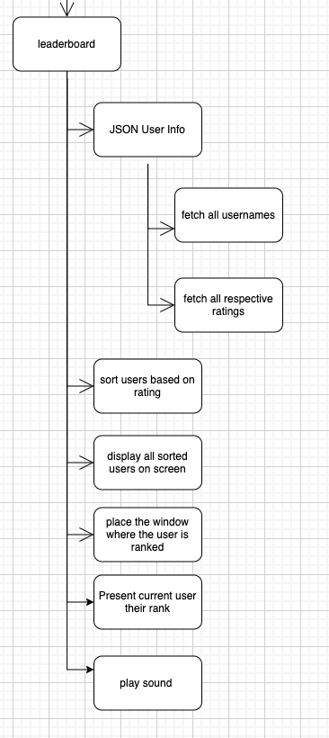

The Leader board will have to carry out the function of displaying all the usernames, inactive and active, with their respective Elo rating in rating descending order.

It will produce a sound when pressed to allow the user to know that the request has gone through, so he is not waiting and questioning whether the press has been detected or not.

It will first need to access the JSON file labelled User Info to be able to access all the user’s data. Then only fetch the username and rating of all users. The program will display this on screen with a presentable GUI.

The users will be placed into pages that will contain 20 users each. There will be a button which places the current users screen onto the page he is currently placed in to make sure the user can easily and quickly find out where he stands in the rankings and to make using the leader board better, to save the user time and making the page more user friendly.

The refreshing of the Leader board will not happen in real time but every time the user requests to see the leader board i.e., pressing the leader board button. This is because designing the leader board to run in real time is out of the scope of this project and adds extra complexity that I do not have the time for. However, if implemented in the future this would require us to use threading and continuous communication with the main computer, the server.

#### Load Game

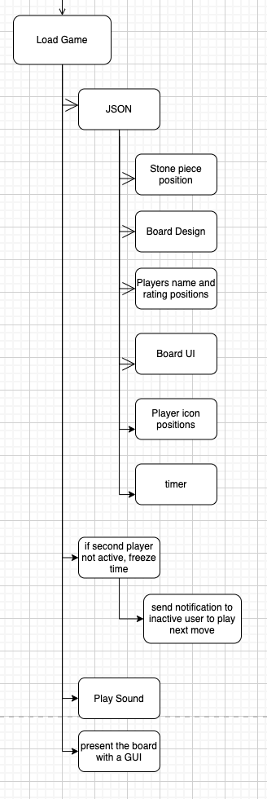

|  |  |  |
| --- | --- | --- |
| *Functions* | *Explanation* | *Justification* |
| Play sound when pressed | To give feedback to the user to say that it is now loading the previous game | Allows for certainty that the request has been made. Not leaving the user confused or questioning whether his press has worked |
| Present board with GUI | Shows the board with all the previous pieces displayed with all other information | The user can easily see and understand the board with a GUI which makes it more user friendly. |
| Fetches data from JSON file | Gets all the data required to present a playable game from a JSON file | Without this data the user will not be able to start playing the game again |
| Stone position data | To allow the user to see where the previous stones have been placed to decide on the next move | Allows the user to see and calculate their next move, without it they would have an empty board |
| Freeze timer if not present | If the two users are not present at the same time, the inactive user will have their time stopped, therefore not allowing the active player to move, until they are back into the game | This will keep the game fair as this stops users being able to play consecutive moves without the other player which is cheating. |

#### New Game

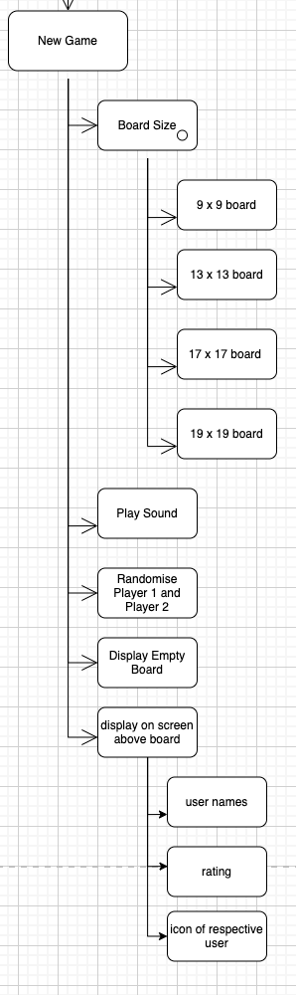

|  |  |  |
| --- | --- | --- |
| *Functions* | *Explanation* | *Justification* |
| Forces user to enter a board size | The computer will not begin looking for a new game until the user has entered how big they want their board to be | Without this function, it is not possible to play a game as the computer will be unable to match an opponent to the user |
| Plays a sound when button pressed | To give feedback to the user to say that it is now going to present the new game screen | Allows for certainty that the request has been made. Not leaving the user confused or questioning whether his press has been received by the user |
| Randomises player 1 and 2 | When starting a new game, the program will randomly choose a player to start the game as white | This allows the user to experience playing the game from both ends of the board. It makes the game a more enjoyable experience |
| Display empty board | When it has found 2 players, it will present an empty board with a GUI on screen to both users | Let’s the users know that the game can now begin and that they are starting a new game |
| Fetches and displays the players usernames and ranks from JSON file | When the game begins, it will show both players their names and rating at the top of the board | This will let the users know who they are playing against and how good their opponent is very easily, increasing usability |
| Only allows for 4 different sized boards | When choosing what board size to play on, the user must choose from a list of options | Increases the chance of finding an opponent as there is a finite number of sizes. If the board size entered is too big or small a game may not be playable as there is not enough possible moves or the screen size does not show enough detail for large boards e.g., 100x100 |

#### Account

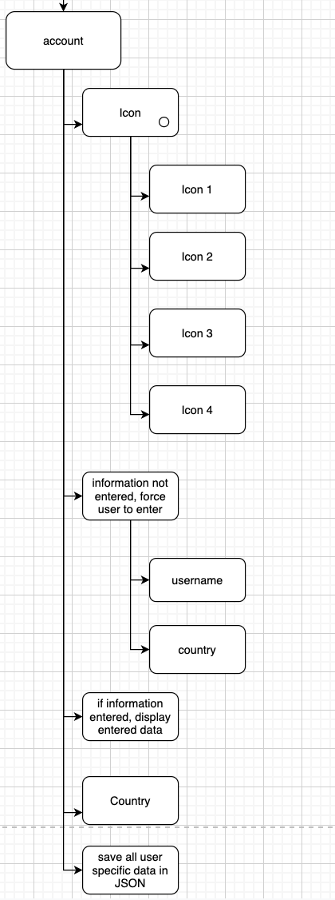

|  |  |  |
| --- | --- | --- |
| *Functions* | *Explanation* | *Justification* |
| Allows the user to choose an icon | lets the user choose an icon out of 4 possible options from a drop down menu | Increases usability and makes the user personalise their account letting them enjoy playing their games more. Making the experience more personal. |
| Forces the user to enter their username | When on the account page, if the user hasn’t entered a name, the program won’t let them exit the page without entering a name unless quitting the game | This allows the user to be uniquely identifiable to other players in the game and it will cause less confusion within the game when pairing players to play a game |
| Makes the user enter their nationality | This will give the user a range of countries to look at to be able to find their country | This makes the game more personable; it makes the user have a more personal and enjoyable experience in the game |
| Make the country selection a drop-down menu with a search bar | When the user looks for a country a drop-down scrolling choice will appear with a search function at the top of the section to type in to let the user search for it | Makes the experience more enjoyable and less stressful. If the user is from a country at the bottom of the alphabet, then they will be scrolling past many countries to get to theirs, this will speed up the process, thus making them have a more positive experience |

### Gameboard

The Gameboard is a complex part of the game and has been subdivided into Menu, Timer, Place Stone, Pass Move and End. This is, what I think, will be the 5 main functions of the game board and they will be the most effective parts of the gameboard

#### Menu

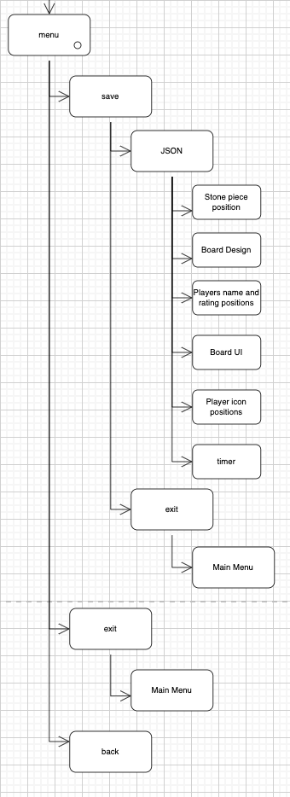

|  |  |  |
| --- | --- | --- |
| *Functions* | *Explanation* | *Justification* |
| There will be a toggle menu in the corner of the screen which will give them multiple options to choose from | There will be a menu icon in the top corner of the screen which allows the user to exit, save or go back into the game | Allows the user to very visibly and easily control when they want to leave the game, and it gives them options during the game, so they don’t have to wait for the entire game to finish before they can leave |
| When saving a game, it will store all the respective pieces | To store the stone positions, board design, player name and ratings, board UI, their icons and the timer condition | The next time they start the game, this is the essential required for the two players to be able to continue their game |
| When pressing save, this will make the user go back to the main menu by default | If at any point the user wants to save the game, it will not only save but it will also prompt them back to the main menu | This is because it is assumed that the user wants to exit the game if they are going to be saving as they are typically two related tasks |
| There will be a back button | If the user wants to go back to the game and not leave or save | This is if the user changes their mind and wants to continue playing the game, it will allow them to go back and not force them to leave |

#### Timer

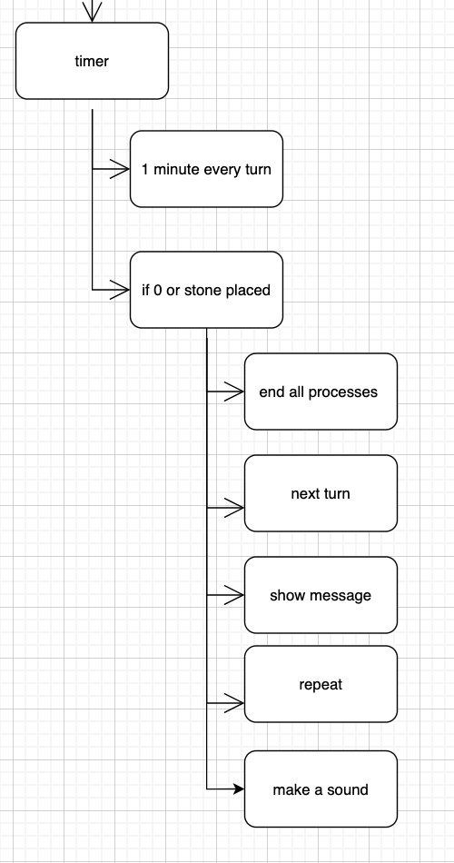

|  |  |  |
| --- | --- | --- |
| *Functions* | *Explanation* | *Justification* |
| Each turn is one minute | Each user has a one-minute time slot to play their go or else they are skipped | Makes sure the user doesn’t waste any time or bore the other user by taking too long |
| A sound is produced with a message when the timer is done | When the timer has reached zero or when the user has played a move a message ‘next turn’ with a noise will be generated | To make sure the other player knows their timer has started. To make sure they realise it’s their go now, make it easier to play a game as they might be thinking about their next move they will forget its their go, so this will remind them and let them not worry about skipping their go |

#### Place Stone

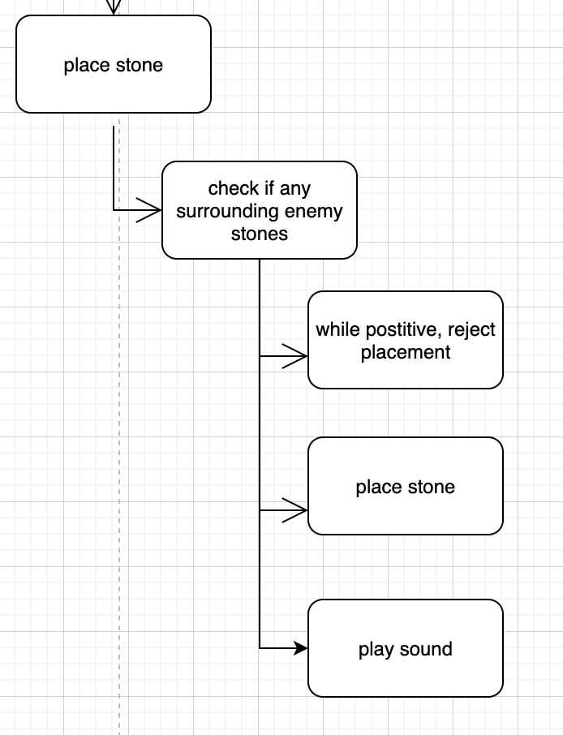

|  |  |  |
| --- | --- | --- |
| *Functions* | *Explanation* | *Justification* |
| Play sound when placed | Whenever either user places a stone, a sound will be played | This is to give feedback to the user, to allow them to know that their move has been processed and has been placed |

#### Pass Move

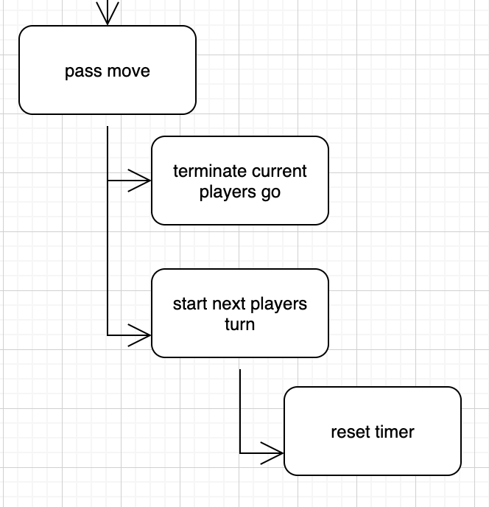

|  |  |  |
| --- | --- | --- |
| *Functions* | *Explanation* | *Justification* |
| Terminate current players go | When the player has passed, it will end his go and not allow him to place any stones | If he was still able to place stones while its the other players turn, it would be and illegal move |
| Start next players turn | When the first player has passed their move, we allow the next player to take their turn | As the first player has decided to forfeit their go, this therefore means the other player can now take their turn. Without this they would not be able to move |
| Reset timer | When it’s the next players turn, we reset the timer to countdown from a minute again | We cannot have the time left from the previous user carry on into the second user as that would be unfair and the incorrect way to play the game |

## usability

### Main Menu

I created two different main menu pages and decided to create a poll to see what the opinions of some of my stakeholders would be. The idea being the first main menu design is a more simplistic design trying to imitate the simplicity of the game Go while the second menu is a more modern looking approach, primarily aiming to the new or inexperienced stakeholders.

A consideration I have used in both designs in that making the title larger than the button on the screen. This is because it will make the title have a higher weighting to the user, thus attracting them to the title. I have researched this and found that the website [www.jotform.com/blog/mixing-multiple-fonts/](https://www.jotform.com/blog/mixing-multiple-fonts/) also says that using different sizes and fonts to emphasise the weighting of your text is a needed consideration.

#### Main Menu 1

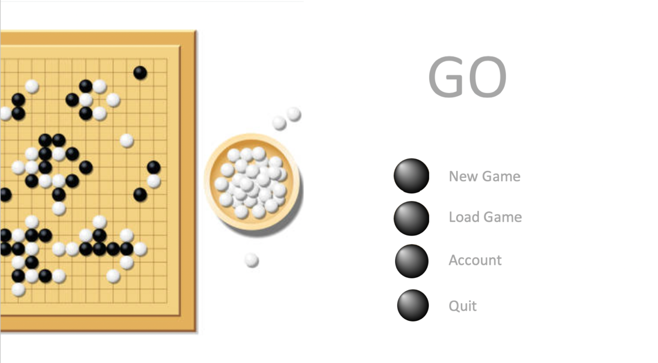

|  |  |
| --- | --- |
| *Feature* | *Justification* |
| The title is the largest text size | The first thing the user sees when entering the app to know its Go |
| The options directly below the title | For the user to see all the options available very easily and quickly |
| Top-down view of go board as background | For the user to know that its Go and to make the main menu inviting, and this would be the layout they would have when playing the game on the app |
| The buttons are laid one after the other in a line | This allows new users to easily find the buttons and figure out what button does what action |
| The options are black text font with stones as bullet points | Making the overall experience of the user better as the text options would also be Go themed making it more |
| Black and white theme | To imitate the go stones as they are black and white, to also add some contrast to the screen |
| The text is grey on the white background | This is allowing the user to be able to read and identify the buttons easier which then attracts the user’s attention to the button, making it more user friendly |

#### Main Menu 2

When designing the second main menu, I am going to use a research paper conducted by Google and aim for a more modern looking UI. The research should make the UI more intuitive and easier for the users to interact with, thus making them enjoy using the program more.

##### Google Golden Triangle Research

In 2005 google conducted a study to see where their users looked at on their results screen directly after searching for something. The results were that people looked at the top left of the screen the most often.

The results have been represented as a heat map, with the redder areas showing the number of users looked at that region of the screen directly after searching.

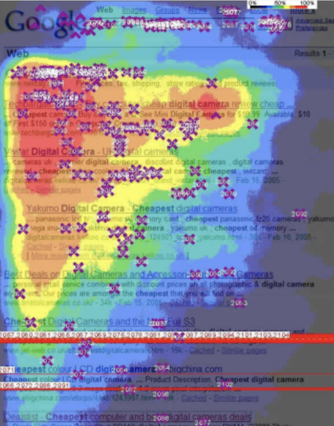

The results show that most users tend to look at the top left-hand corner of the screen.

There has been a lot of criticism on this research which says that the most looked area is the top left because the population sample were all English readers reading from left to right, so this would cause a bias within the results. They suggested that if they used a population sample that included right to left readers, this would change the result, thus making the golden triangle invalid. However, my stakeholders are all English, left to right, readers so it will not affect them and the top left-hand corner being the most looked at region would still be true.

This will help my UI to be much better as it means that users will find it easier to use the main menu, increasing usability.

##### The Design

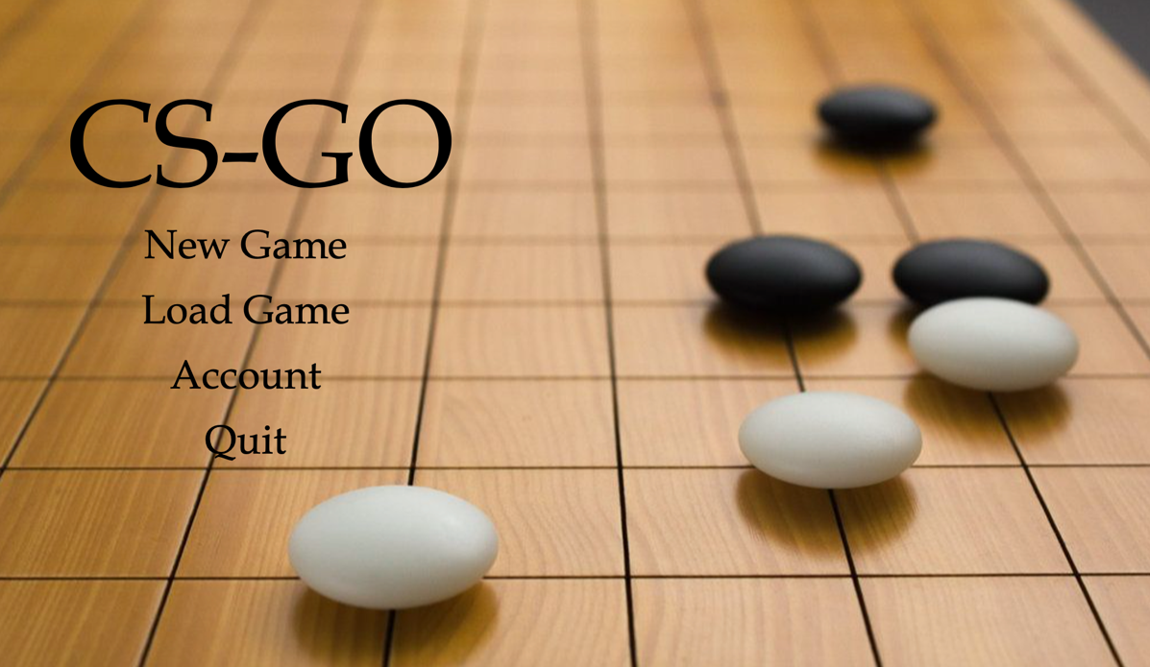

Figure 10 Main Menu 2

|  |  |
| --- | --- |
| *Feature* | *Justification* |
| The background being a board at an angle | It is a more professional look, as it is brown it has less contrast as well which makes it easier to look at, softer on the users eyes |
| The GO title being larger than the rest of the text | To make sure the title and the name of the game is the first thing being seen by the user |
| The menu options are in the top left corner | This is based off the research Google has conducted |
| The text is black | The text being black also makes the words easier to read for the user as the black on brown has less contrast so is softer on the user and attracts their attention |
| The font being used is Castillo MT | This is creating them of being ancient yet at the same time trying to be modern, directing at the stakeholders who would like to have the feeling of how long lived the game is, to try and keep its originality |

##### The Poll

This was held on Reddit; I believe this was a good choice as it would contain hundreds of people who fit my stakeholder criteria of being novices. I was unable to collect data from other stakeholders as there was not a large quantity of them concentrated in one area, making this data collection take too long and is not within the scope of this solution.

This poll only lasted for 3 days before entries were closed, this also due to the nature of the solution as there would not be enough time to continue this for longer and that I believe that this is enough time to get a representative view of the groups’ opinions.

I asked whether design 2 was better than design 1 and the reasoning behind it, allowing them to add their own personal comments as well, 299 people voted in this poll.

The poll had 4 options, including their results:

1. Colour scheme (47)
2. Font (37)
3. Background image (101)
4. Button, background, and title layout (114)

#### Pie chart representing the results

Most voters said that they liked the second page for in the order of importance as stated above. This therefore showed the importance of the research that I took into consideration, the golden triangle has significantly helped my main menu as about 40% of voters said that the positioning of the page has improved.

Some general criticism was that menu 2 was lacking contrast and the image was not opaque enough. The font did not make the title and options stand out well, I was instructed to use a more geometric font to make the options and title bolder. The title was also too large and too eye catching, making all the other aspects of the main menu less attracting.

#### The Second Iteration of the Main Menu

Based off the information I received from the criticism, I have amended the main menu.

I have considered:

* The opaqueness of the background, making it more opaque
* The font of the title and options, changing it to Quicksand for a more geometric look
* The contrast within the background
* The size of the title, making it smaller

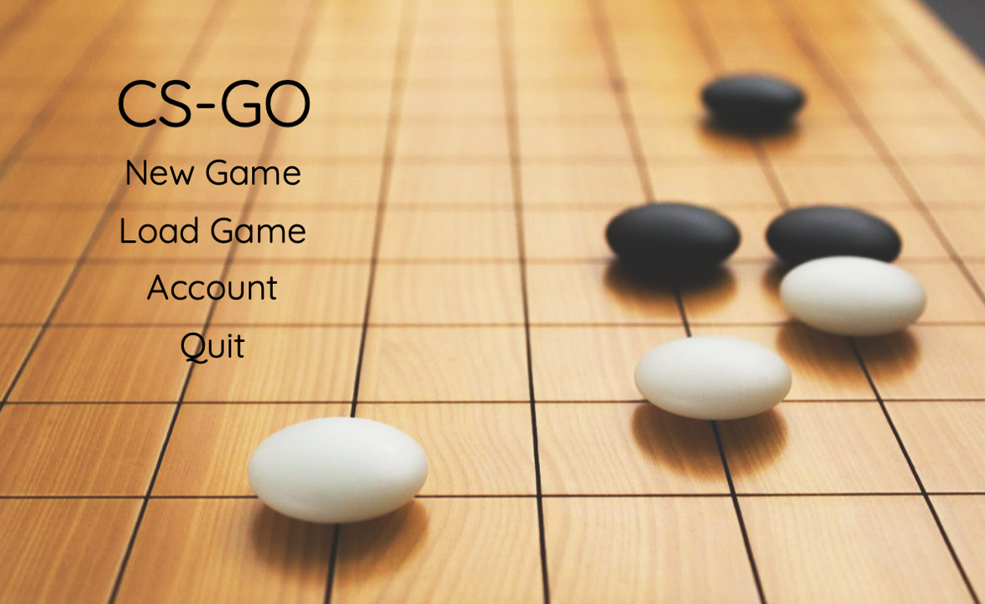

|  |  |
| --- | --- |
| *Feature* | *Justification* |
| Using Quicksand font for the text | This a more geometric font, therefore making it easier to use and more attractive to the user |
| More contrast and opaque background | To make the contrast between the black text and the background higher, making the menu and title more attractive to the user |
| The smaller title size | Makes the title less overwhelming to the user and making the UI easier to read than making the title stand out |

#### Wireframe

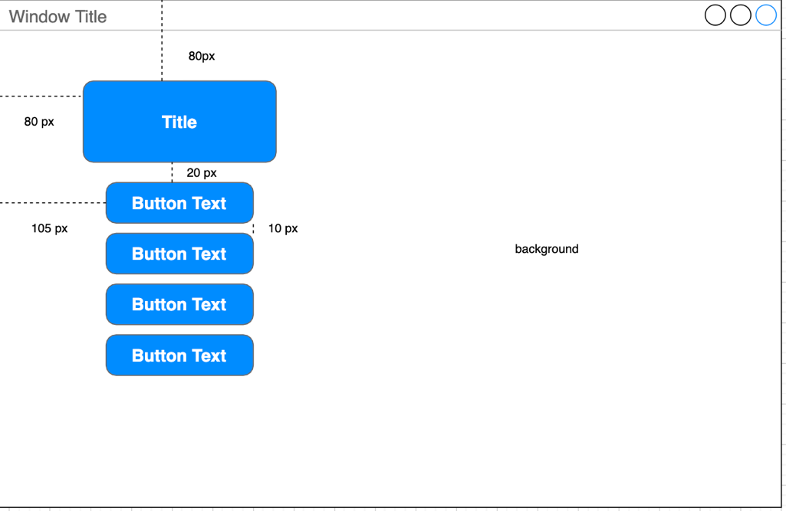

### The Account Page

For the accounts page I will continue to go for the modern look by using a simplistic design and keeping consistency which would allow the users to

#### The first design

1. I have created a first draft of my accounts page. I have considered all the features required: username input, selecting icons, country input, back button, sound options.

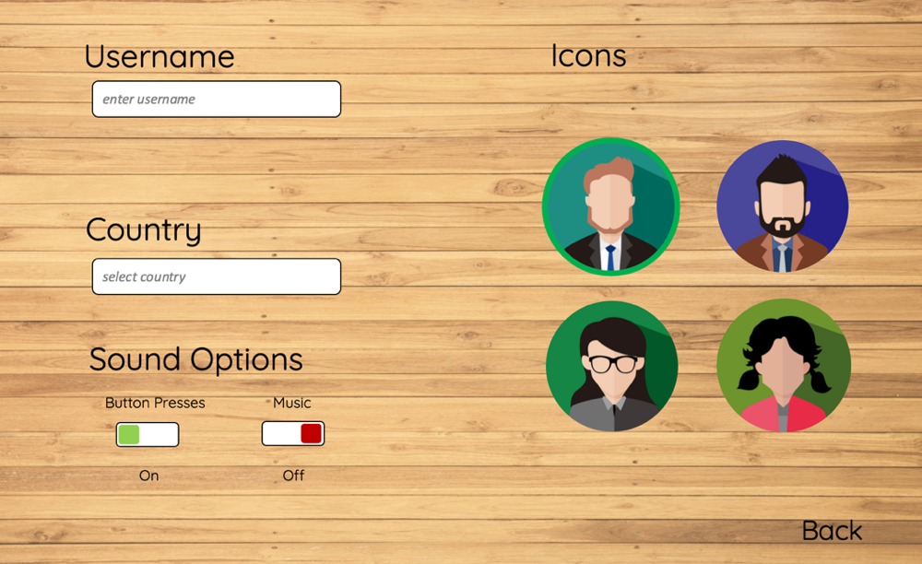

|  |  |
| --- | --- |
| Feature | Justification |
| Rounded edges | The boxes will look nicer and draw the user to the content instead of looking at the hard edges |
| The wooden background | Keeps the theme of having a wooden go board, it keeps a consistent theme of relating back to the go board |
| The colour of the text in the boxes grey and in italics | To show it is a secondary title to the user and that their input is required |
| The sound options to be toggle boxes | this is because many other websites use toggle boxes for binary options, therefore, to make the user less confused I will follow the general convention |
| Having icons in a circle | When presenting the icons on the board during gameplay, so this is to give the user an exact representation of what it will look like on the board |
| Having the selected icon have a green border | This will tell show the user that they have chosen this icon very easily and intuitively as green is a colour to represent go/correct. Using a border is not obstructive and it doesn’t detract from any other features |
| Back in the bottom right corner | To try and not make the left side of the screen too clustered, I’m putting the back button on the right as it balances out the screen |

#### The Second Design

This is an iteration over the first design, here I have changed the font, background, and icons. The reason was that I thought the first design didn’t look very inviting and was very bland. Doing this should make sure the page would be more exciting and would make the user engage more with the page.

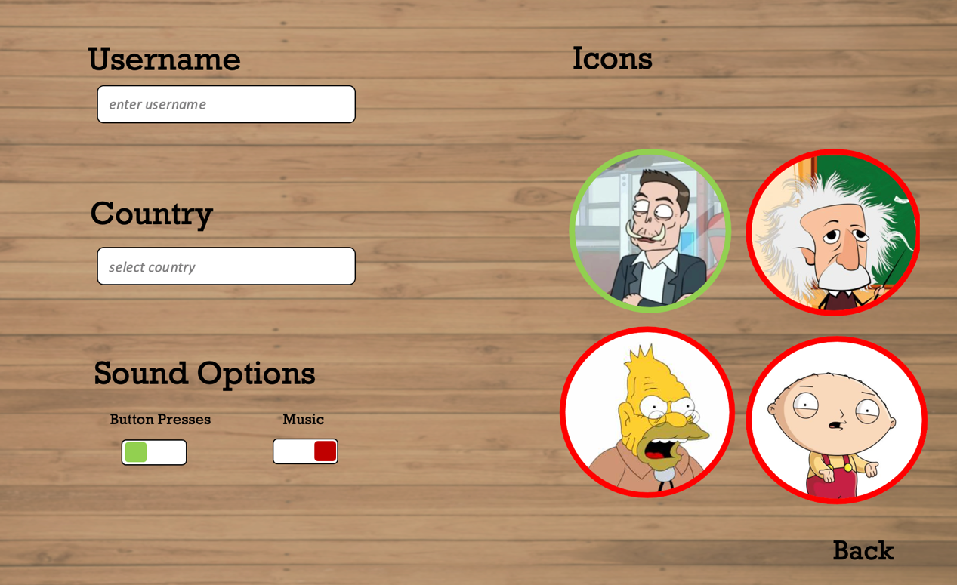

|  |  |
| --- | --- |
| *Feature* | *Justification* |
| The dark background | The darker background makes the page look more inviting and will make the users engage more with it |
| New well-known characters for icons | Instead of using generic characters for the icons, using more popular icons will make the game experience more memorable, therefore making the user engage more with the game |
| Change of font | Using the Quicksand font with the light background looked very sterile so with the less geometric font it looks more inviting and exciting |
| Red circles around unpicked icons | This will very clearly show the user exactly who is picked and who isn’t. It is more intuitive to understand and pick up on than just a singular green circle |

#### Wireframe

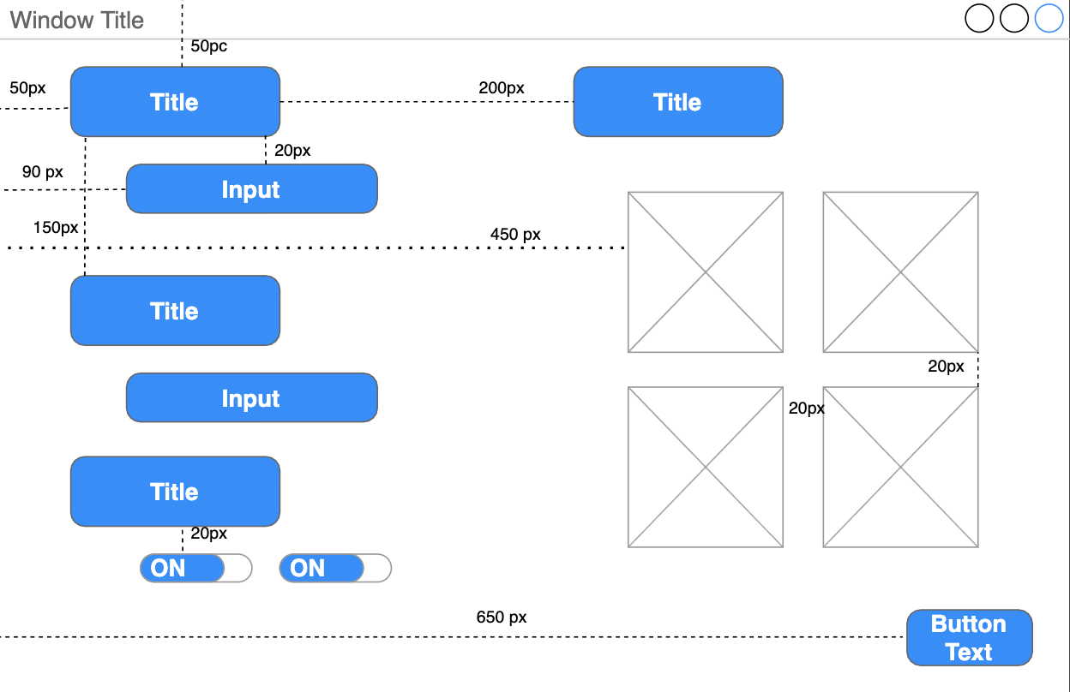

### 2.2.3 New Game Page

#### First Design

Here is the first iteration of the new game page. It includes all 4 sizes of boards, a back button, and a search button. The search button will initially start off as grey until the user has chosen a board, then it will change to black to indicate that they are now able to look for a partner

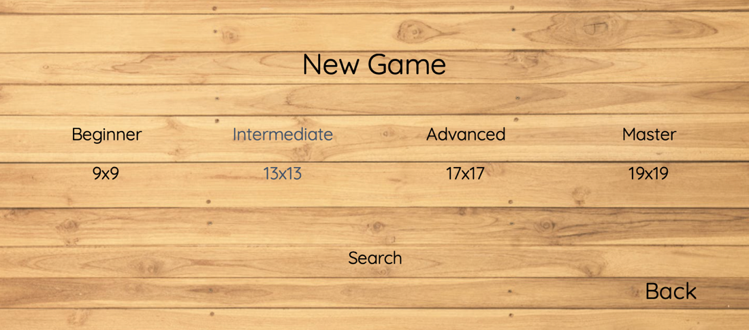

|  |  |
| --- | --- |
| *Feature* | *Justification* |
| New game title on the top | To indicate the user, they are now in the new game section |
| The board sizes with their respective difficulty | Makes choosing a game mode more fun as the user can now relate themselves back to the game and gives a quick and simple description of how difficult playing on each board is to new players |
| Search button on the bottom | The search button, currently lit, will allow the user to begin the search for a partner within the game, it’s at the bottom because it balances out the screen not making it seem clustered |
| The search button will initially be grey when the user hasn’t chosen an option | This is to show that the user cannot start without choosing a game mode, the grey will stand out as it will be different to all the other text, which is black, so it is intuitive to see that there is a discrepancy |
| When selecting a game mode, the chosen mode will change to blue and make a noise | It will turn blue to tell the user that it has been selected. It is blue because it still is easy to read it on the wooden background. It will make a noise to audibly tell the user it has been chosen |
| The wooden background | This is to fit the theme of the wooden go board and make choosing a game mode more enjoyable |
| Back button in the bottom right corner | To be consistent and reduce the memory load on the user as the back button on all pages will be the same |

#### Second Design

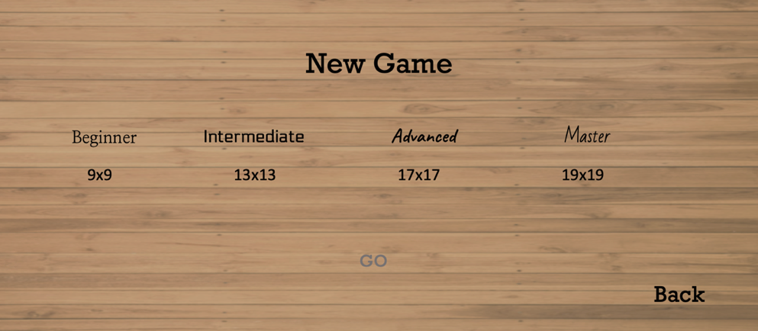In this iteration I have changed the font and background to keep consistency between pages. The main goal of this iteration is to try and make sure the user would want to advance through to the next board sizes and so I will make the more difficult boards look more enticing. This would increase competition within the game and increase user satisfaction as it would be making the page more interactive

Figure 11 when the user first opens the page

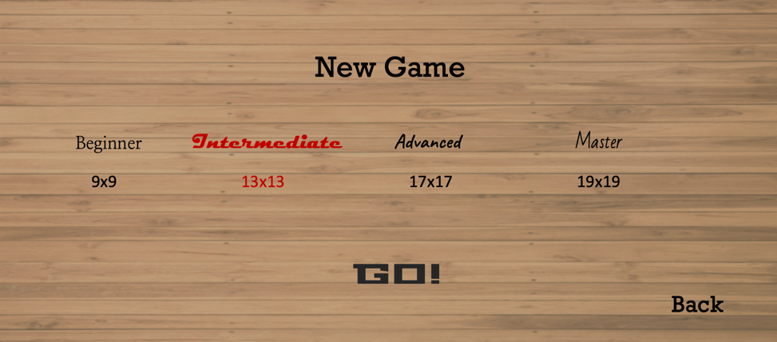

Figure 12 the user has selected intermediate

|  |  |
| --- | --- |
| *Feature* | *Justification* |
| Darker background | The darker background makes the page look more inviting and will make the users engage more with it |
| Rockwell font for the title and the back button | This makes the page more exciting and will make the user engage with the page more |
| The different game modes have different fonts | This will show the user that each game mode is a step up from the previous one should motivate the user to achieve the higher board. It makes the game more competitive |
| The word GO appears on screen when the user has selected a board | This is to motivate the player to enter the game, to try and give off the impression that this is more than just a game will make them more competitive and thus have the drive to want to play more and win |
| The chosen game mode goes red in a different font | This should motivate the user to play this game mode and increase user satisfaction |

I think I will stick to this page as it does a good job of pushing the user to play the game and motivates them to try and push themselves to the next board size. It also has more contrast than the previous page which will be more attractive to the last page.

#### wireframe

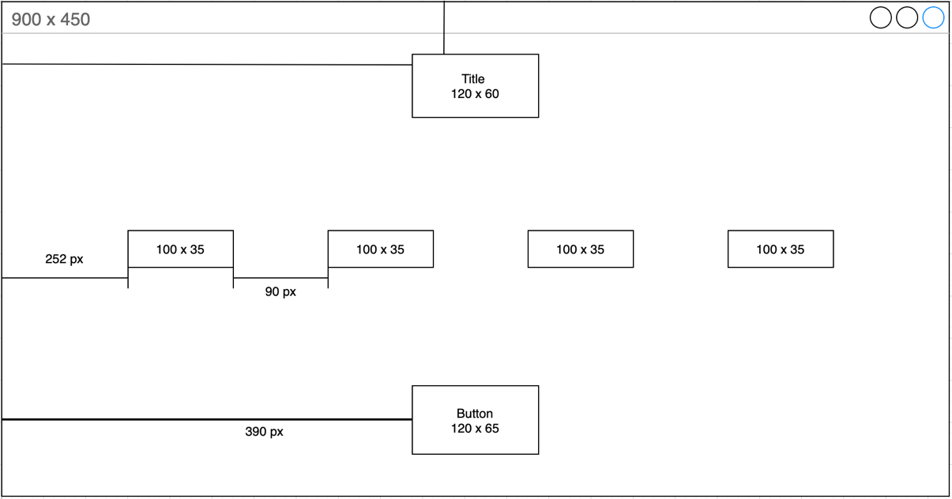

### Load Game Page

This page will not have an interactive page, but a pop up that inform the user that there is not a previously stored game to load, if there is it will automatically load it skipping the page.

#### First design

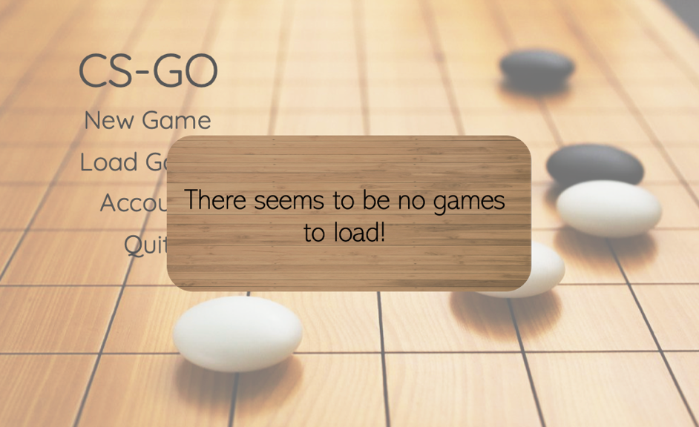

Figure 13 the user has clicked load game, but it denies the option

|  |  |
| --- | --- |
| *Feature* | *Justification* |
| The main menu becomes transparent | This is to bring the users attention to the message box as quickly and as unobtrusively as possible |
| The background is dark wood | The dark wood background will be the theme of all of the first pages to keep is consistent |

### The Game Board

When designing the gameboard, I will only consider the placement of the usernames, icons, timer, and menu. This will initially be done iteratively with a 9x9 board then when I have settled on a design, I will design the other 3 boards.

#### First Design

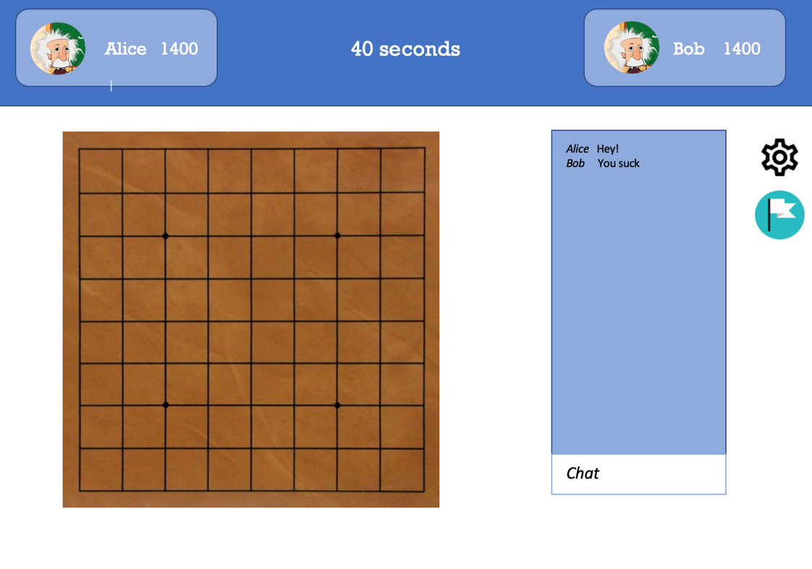

|  |  |
| --- | --- |
| *Feature* | *Justification* |
| Board on the left and everything else on the right | When playing a move or when placing stones, the user can concentrate fully without having any distractions |
| Timer in the middle at the top | This is so it is very clear and easy to see what time they have left, making it easy for the user to keep track of the time wherever they are looking on the screen |
| The actions, surrender and settings, are on the side with the chat | This is to keep all possible actions contained in one area, this reduces the memory load on the user as they will be able to very quickly learn where all the actions are |
| Blue theme | This is to relax the players, if the game were to get intense this should calm them down and relax them as a strong colour such as orange would make them angrier, making their experience negative |
| The board is dark brown | To imitate the real-life board, giving it a more real feeling, increasing user satisfaction as they might like to play on a real looking board |
| The settings icon | This is to show the save/exit options pop up, the gear is a universal symbol for this as it will be consistent with other application, so the user will understand this very quickly, increasing usability |
| The white flag | This represents surrender, this is also a universal symbol of surrendering so therefore the user will understand this very quickly therefore increasing usability and user satisfaction |
| The users with their Elo rating | This allows the users to see how good their opponent is relative to them, letting them now the level of play they should expect from their opponent |
| The usernames are in the corners | This makes sure that all the essential information on the screen, the chat and board, are not clittered with the usernames, making them concentrate on the game easier, increasing user satisfaction |
| The icons with the usernames | This is to make the game more personal, as they would have their own icon next to their name and so increasing user satisfaction |

#### Second Design

In this iteration of the board design, I will try to make the page more exciting and try to make the board more attractive to the user by experimenting with the colour, type, and placement.

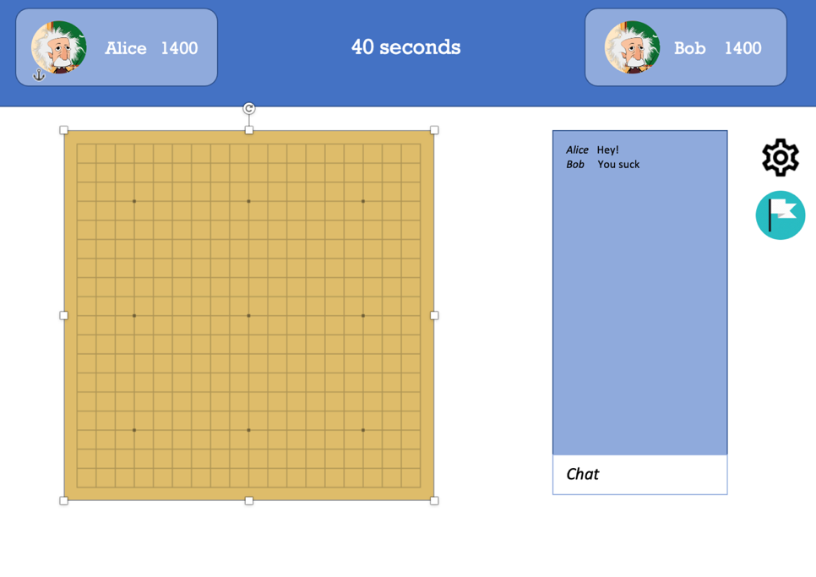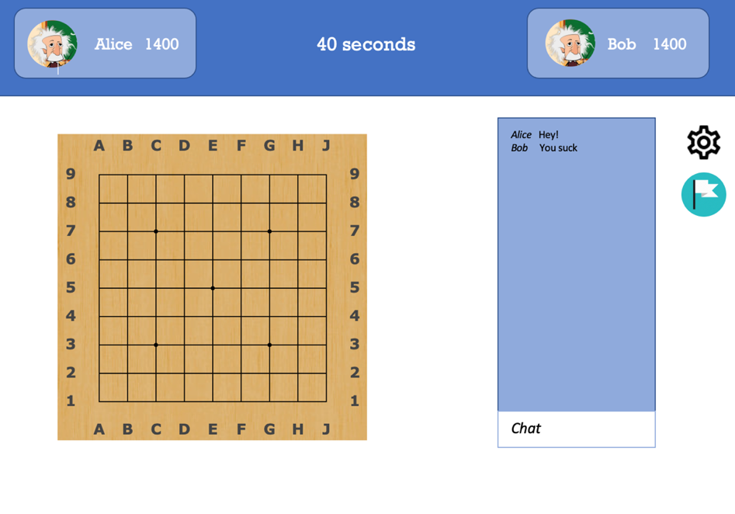

Figure 15 board without label

Figure 14 labelled board

I think I will continue with the labelled board as it allows the users to discuss where they have placed their stones in a more accurate manner. The unlabelled one looks cleaner however is less useful

#### Diagram Description automatically generatedwireframe

## 2.3 Algorithms

### 2.3.1 Finding a valid position to place a stone

This algorithm solves the problem of needing to find a suitable place to place a stone while playing the game. It is required as without it the player would end up placing illegal moves within the game and this would not be correct. This is one part to other multiple algorithms needed to place stones and run the game.

To be able to place a stone in the game, there should not be the oppositions stone surrounding the potential spot. This is done by checking if there is a boundary of the oppositions stones that encapsulates the current player’s position.

For this I will be implementing a variation of the flood fill algorithm. This starts from a specified start node and then spreads outwards to all 4 adjacent nodes checking if the node is a boundary node, the oppositions node, or not. If it is the oppositions node, we leave it alone and pass, however if it’s not we mark it as seen and we continue. If we can get outside of the matrix, the board, then we have found out that the current position is not encapsulated by the other player because if it was, we would have not been able to make it off the board

#### Variables

Board: 2d matrix (INPUT)

Size: int

Turn: int (INPUT)

Stone: arr

Condition: bool

Row: int (INPUT)

Col: int (INPUT)

#### The solution

In this solution board, turn and the inputs to the function dfs are variables that change during gameplay

The recursive solution pseudocode

SET board TO [[1,1,1,1,1,1,1,1,1],

[1,0,0,0,0,0,0,0,1],

[1,0,0,0,0,0,0,0,1],

[1,0,0,0,0,0,0,0,1],

[1,0,0,0,0,0,0,0,1],

[1,0,0,0,0,0,0,0,1],

[1,0,0,0,0,0,0,0,1],

[1,0,0,0,0,0,0,0,1],

[1,1,2,1,1,1,1,1,1]]

SET size TO len(board)

SET turn TO 1

SET stone TO [1,2]

SET condition TO False

DEFINE FUNCTION dfs(row,col):

GLOBAL condition

IF row >= 9 or col >= 9 or row <= -1 or col <= -1:

SET condition TO True

RETURN

ELSEIF board[row][col] != stone[turn ^ 1]:

IF board[row][col] EQUALS 0:

SET board[row][col] TO 3

dfs(row + 1, col)

dfs(row - 1, col)

dfs(row, col + 1)

dfs(row, col - 1)

ELSEIF board[row][col] EQUALS stone[turn]:

SET board[row][col] TO 4

dfs(row + 1, col)

dfs(row - 1, col)

dfs(row, col + 1)

dfs(row, col - 1)

ENDIF

RETURN

ENDIF

FOR row IN range(size):

FOR col IN range(size):

IF board[row][col] EQUALS 3:

SET board[row][col] TO 0

ELSEIF board[row][col] EQUALS 4:

SET board[row][col] TO stone[turn]

ENDIF

The step of the recursive code is:

1. If the current position being checked is out of bounds, we have reached the end of the board
   1. Set condition = true
   2. return
2. If the current position being checked is anything but the stone of the opposition
   1. If its empty
      1. Change it to 3 so we don’t go over it at a later stage
      2. Carry out the check for the neighbouring positions
   2. If it is the stone of the current player
      1. Change it to 4 so we don’t go over it at a later stage
      2. Lk.;Carry out the check for the neighbouring positions
3. return

|  |  |
| --- | --- |
| Pros | Cons |
| It is easy to implement | It uses a recursive stack to hold all the calls |
| Linear time O(n) | We must scan through the board a second time to change back all the changed stones or empty slots, this takes extra O(n) time |
| O(n) space due to stack in memory | It potentially scans through all the positions 4 times |

### 2.3.2 The main menu

This is a very straightforward algorithm. This will allow the user to interact with the main menu, being able to start and load games and exit.

#### Variables

Newgame: bool

Loadgme: bool

Leaderboard: bool

Quit: bool

Newgame():

Loadgme():

Leaderboard():

Quit():

#### The solution

Pseudocode

SET NewGame TO False

SET Loadgame TO False

SET Leaderboard TO False

SET Quit TO False

IF NewGame:

NewGame()

IF LoadGame:

LoadGame()

IF LeaderBoard:

leaderBoard()

IF Quit:

Quit()

In this solution, if the Boolean variables are ever true, the user has clicked the button, then it runs the respective functions.

### 2.3.3 Calculating Elo Rating

Calculating the Elo rating will help us rank the players and will allow the users to see how good they are relative to all the other users. It will solve the problem of comparing the relative ability of the users.

#### Variables

ratingA: int

ratingB: int

ratingDiff: int

denominator CONST: float

expectedA: float

outcome: int

k CONST: int

newRatingA: int

#### The solution

Pseudocode

SET ratingA TO 1300

SET ratingB TO 1200

SET ratingDiff TO ratingB - ratingA

SET denominator TO 1 + (10 ** (ratingDiff/400))

SET ExpectedA TO 1 / denominator

SET outcome TO 1

IF ratingA >= 1600:

SET k TO 16

ELSE:

SET k TO 32

ENDIF

SET newRatingA TO k * (outcome - ExpectedA)

SET ratingA TO INT(newRatingA)

store ratingA

### 2.3.4 Account

This will allow the user to enter their username, search for a country, select their sound options and choose an icon

#### The solution

The Pseudocode

USERINPUT username

SET countries TO ["Afghanistan", ... ,"Zimbabwe"]

SET currCountry TO []

SET curr TO ''

WHILE True:

SET currCountry TO []

IF INPUT:

USERINPUT letter

ENDIF

IF delete:

SET curr TO curr[:-1]

ENDIF

FOR country IN countries:

IF len(curr) <= len(country):

IF curr EQUALS country[0: len(curr)]:

currCountry.append(country)

SET whenClick TO True

SET music TO True

IF musicButton:

SET music TO not music

IF whenClickButton:

SET whenClick TO not whenClick

SET icons TO ['icon_1','icon_2','icon_3','icon_4']

SET iconChosen TO 'icon_1'

IF icon1:

SET iconChosen TO 'icon_1'

ENDIF

IF icon2:

SET iconChosen TO 'icon_2'

ENDIF

IF icon3:

SET iconChosen TO 'icon_3'

ENDIF

IF icon4:

SET iconChosen TO 'icon_4'

ENDIF

### 2.4.5 Finding the number of connected components

This algorithm will allow me keep track of number of groups within the board including which positions are being used for which group. Meaning that at the end of the game I will be able to calculate the area of these groups very quickly and efficiently.

The input to this will be the state of the board as the end.It will return a 1d array that has every position in the board describing which stone is its starting stone for the connected group

#### The solution

SET rows TO size of board

SET cols TO size of board

SET parents TO [float('inf')] * (rows*cols)

SET parents TO deque(parents)

SET ones TO Arr

DEFINE FUNCTION find(x):

IF parents[x] < 0 or parents[x] EQUALS float('inf'):

RETURN x

ELSE:

RETURN find(parents[x])

FOR i IN range(rows):

FOR j IN range(cols):

IF board[i][j] EQUALS 1:

ones.append( ((i*cols) + j) )

FOR i IN ones:

SET flag TO 0

IF (i+1) % cols EQUALS 0:

PASS

ELSEIF i + 1 IN ones:

SET p1 TO find(i)

SET p2 TO find(i+1)

IF parents[p1] EQUALS parents[p2] EQUALS float('inf'):

SET parents[p1] TO -2

SET parents[p2] TO p1

ELSEIF parents[p1] EQUALS float('inf'):

parents[p2] -= 1

SET parents[p1] TO p2

ELSEIF parents[p2] EQUALS float('inf'):

parents[p1] -= 1

SET parents[p2] TO p1

ELSEIF p1 EQUALS p2:

PASS

ELSE:

parents[p1] += parents[p2]

SET parents[p2] TO p1

flag += 1

IF i + cols IN ones:

SET p1 TO find(i)

SET p2 TO find(i+cols)

IF parents[p1] EQUALS parents[p2] EQUALS float('inf'):

SET parents[p1] TO -2

SET parents[p2] TO p1

ELSEIF parents[p1] EQUALS float('inf'):

parents[p2] -= 1

SET parents[p1] TO p2

ELSEIF parents[p2] EQUALS float('inf'):

parents[p1] -= 1

SET parents[p2] TO p1

ELSEIF p1 EQUALS p2:

PASS

ELSE:

parents[p1] += parents[p2]

SET parents[p2] TO p1

flag += 1

IF flag EQUALS 0 and parents[i] EQUALS float('inf'):

SET parents[i] TO -1

RETURN parents

## 2.4 Classes and Data Structures

The solution will be coded using separate classes and methods for Game, User and Actions. This is because I can reuse the same code for creating a and storing Game and User info saving space and time in the development stage. This is good as it will help my stakeholders who have low memory space be able to use the game.

I will also put all the game algorithms in one class labelled Game Outcomes, this will handle events such as move validation.

### User Class

#### Attributes

|  |  |  |
| --- | --- | --- |
| *Name* | *Data Type* | *Justification* |
| Username | String | Will hold the entered username of the user |
| Rating | Int | Will hold the current rating of the user, will be set to 400 to begin with |
| Icon | Png | Will be the icon the user has chosen |
| IfStart | bool | Will be whether the user will begin as the staring player or not |
| stonesCaptured | int | Number of stones the user has captured of the other player |
| ifPassed | bool | To hold True if the player has passed their move, skip their turn |
| movePos | Arr | Holds the x,y position of the next proposed move of the player |

#### Methods

|  |  |  |
| --- | --- | --- |
| *Name* | *Function* | *Justification* |
| NewRating() | This will calculate the new rating of the user with the input of the two players rating | This will allow the user to increase or decrease their rank based on their performance, making their rating variable |
| setIcon() | Will change the current icon of the user to the desired one | Will allow the user to store and change their icons at will |

### Game Class

#### Attributes

|  |  |  |
| --- | --- | --- |
| *Name* | *Data Type* | *Justification* |
| Turn | int | Allows the current player to make a move |
| Board | 2d Arr | Holds the curr state of the board |
| time | int | Holds the amount of time left per turn |
| size | int | To hold the size of the board, such 9x9 etc. |
| numPassed | int | To hold the number of sequential passes in a game |
| ifMenu | Bool | this only has two states pressed or not pressed therefore a bool is useful here. True being the menu icon has been pressed |

#### Methods

|  |  |  |
| --- | --- | --- |
| *Name* | *Function* | *Justification* |
| End() | Check if it’s the end with either 2 successful passes or no valid moves left and get the winner | Allows the users to finish the game and find out who won |
| ghostStone() | Will place an opaque stone on top of the position the player is currently hovering over | Will allow the user to see where they are going to place the stone without needing to actively play it |
| Menu() | It will present the user with the board menu screen | to be able to call the menu method if the user has pressed on the menu button |

## 2.5 File storage

### Main Folders

The way I will be storing the game will be in 2 separate folders. The first one will be called gameProgram and this will store all of the code that is required to run the game such as the classes and functions. The other file will be called information, this will contain the pictures and PNG files.

gameProgram will read from information as it will need to use things such as the images for the icons and will need to read the usernames of users. gameProgram will write to information as it will write data such as the username and game state to the folder so it can be fetched later.

### gameProgram Structure

the main.py python folder will contain the main menu code, this will allow for the start of the program. This will be able to run loadgame.py, account.py, newgame.py and leaderBoard.py. This allows me to be able to separate the tasks and test them independently.

loadGame will read from gamesinfo.json and it will fetch data that contains the info to the last saved game by the user. It will therefore tun the gameRoom.py with the stored game information so it can load the saved game. I will be using a json file as it is compatible with python 3 and it lets me easily access the information as a dictionary within python which is easier to code.

The leaderboard.py will read from the accountinfo.json as it will need to get the rank and usernames of all the players and sort them and then place them on screen.

Account will directly write to accountsinfo.json and will change attributes like the username and icons.

Newgame will read from accounts info be able to get the info of the users and send it to the game room where the users can play the game.

The functions.py file will hold the functions required for the game to work, such as the flood fill algorithm. This will allow me to individually call each algorithm while running the game. This is good when I will be testing as it will allow me to be able to independently test each function and see if it has been written properly. This will also declutter the gameboard file as it will only be used to play the game and not for anything else.

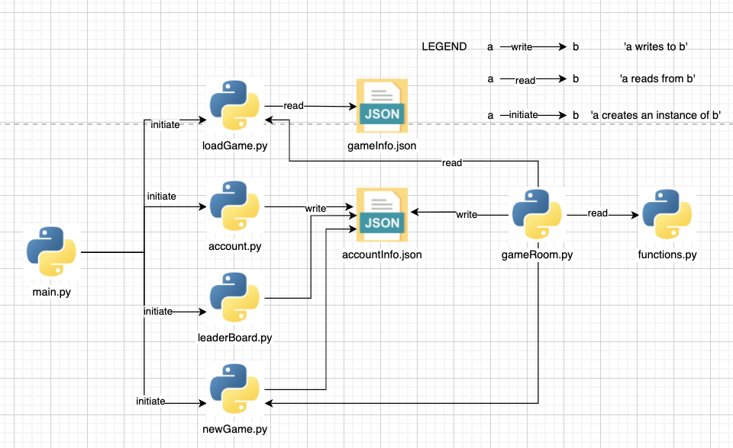

### Information structure

For information structure I am going to split up my images into 4 main subfolders, user icons, boards, stones, and buttons. This is because I think these are the main components that encompasses all the images required to play the game. This will benefit me while coding the solution as it will be very simples to look for and call images that are need from files as the folders are self-descriptive. This will also help in the testing phase as I can spot out any error relating to what page of the game very quickly as its been labelled descriptively.

I will be using portable network graphics, png, as this allows for lossless compression which therefore mean when I am using high quality images it will not lose the quality of the image. This also works very well with python3 so when developing the solution, it will be much easier to use png that anything else.

In the user Icon folder, I will have 4 images called icon1.png, icon2.png, Icon3.png and icon4.png. This will hold the 4 options the user has to choose from the accounts page.

Within the boards folder I will have 4 images which holds the 4 board sizes, 9x9, 13x13, 19x19, 20x20. This is good as it will let me easily access them while programming.

The stones folder will have the 2 icons for the stones, the black and white one. This is in its own separate folder as it would be easier for me to look for and code showing the stones to be on screen. The stones don’t explicitly fit in any other folder, so having their own folders seems the most logical

The buttons will store all the buttons needed. There will be 5 different subfolders, a folder for each complex page. Here a complex page has multiple buttons which allows for high interactivity from the user.

The main menu is complex therefore it will have its own folder, having different buttons for options such as Load Game, Quit and New Game. New Game represents the new game page, including buttons such as beginner, master and Go. Board Game has its own folder as it must be able to present the images of the of the user boxes in the corners as well as pass and menu buttons on the board. Account has its own folder as it will contain the input text box for the username but also the toggle buttons for the music options

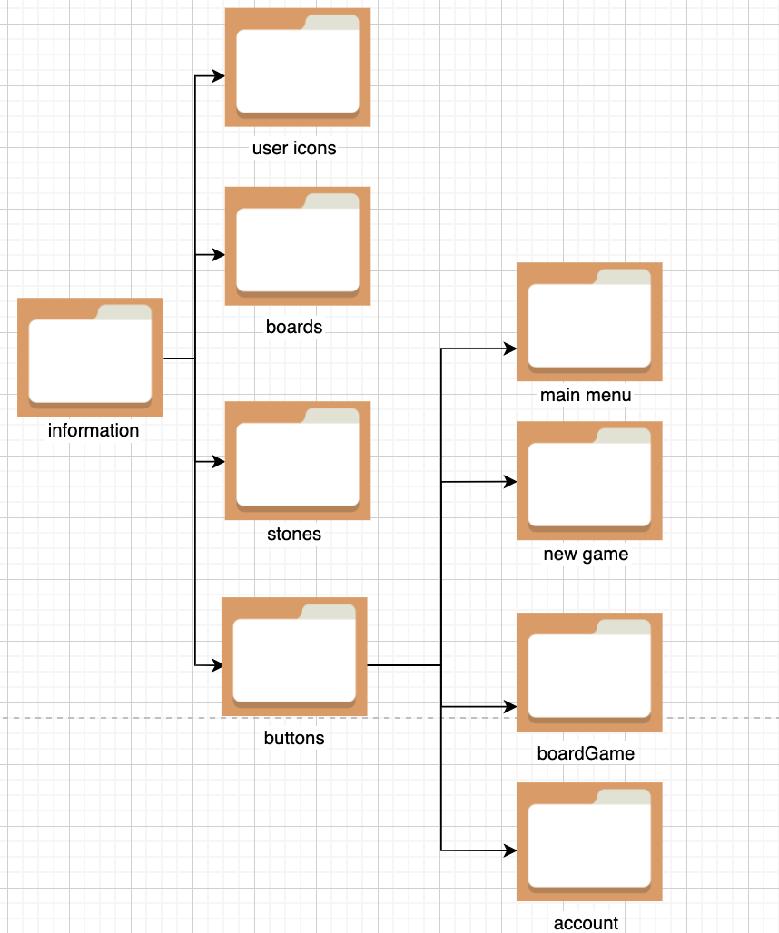

### JSON file structure

#### Game Info

|  |  |  |  |  |
| --- | --- | --- | --- | --- |
| *Field* | *Type* | *justification* | *Validation* | *Justification* |
| currGo | int | has the index of the current players go | 0 or 1 | Only 2 players therefore the array will only contain 2 names |
| size | int | The board sizes are 9 13 19 and 20 therefore it makes sense to use the actual sizes | Only ints 9,13,19,20 | If it takes any other value it will not be a valid board size |
| board | 2d arr: ints | It will hold the board game array | 2d array with only 0,1 and 2’s |  |
| timer | int | To know which second we are at in the current movew | Integers 0 to 60 | if its any smaller its negative time, if its larger its not within a minute |
| users | Arr: string | Only 2 players, so I will store their usernames within this array so I can call them later on in the accounts file |  |  |

#### Account info

|  |  |  |  |  |
| --- | --- | --- | --- | --- |
| *Field* | *type* | *justification* | *validation* | *justification* |
| username | string | Holding characters, so a string is logical, it will store users username | Any string type | User can have integers within their username, so any string is valid |
| icon | string | It will have the name of the file in string format, eg ‘icon4.png’ | One of icon 1,2, 3 or 4 | If it is anything else it will not call an icon, therefore the user will not have an icon |
| rating | int | Ratings are integers | All integers from 0 onwards | The rating of a user can be indefinitely high |
| music | bool | This can only be to states, true or false so bool is logical | Only True or False |  |
| Button press sound | bool | This can only be to states, true or false so bool is logical as it only has 2 states aswell | Only true or false |  |

## 2.6 Testing

Here I will be testing each main function independently outlining the reasoning behind the test input and the significance of the result.

I will be testing the functions independently and the methods within each class independently. This works because I am using OOP in my solution, this allows for modular testing so I can see how each method/function operates on its own.

If the methods and functions all work on their own, then therefore when using the same code to combine them all together, they should all work together.

### Function Testing

#### Valid Position

*in these tests, assume we are player 1

|  |  |  |  |  |  |
| --- | --- | --- | --- | --- | --- |
| *Test Type* | *Input* | *Reasoning* | *output* | *Expected output* | *improvements* |
| Pass test | Pos = [4,5]  Board = [[0,0,0,0,0,0,0,0,0],  [0,0,0,0,0,0,0,0,0],  [0,0,0,0,0,0,0,0,0],  [0,0,0,0,0,0,0,0,0],  [0,0,0,0,0,0,0,0,0],  [0,0,0,0,0,0,0,0,0],  [0,0,0,0,0,0,0,0,0],  [0,0,0,0,0,0,0,0,0],  [0,0,0,0,0,0,0,0,0]] | To check if we can place a stone on the board |  | valid |  |
| fail Test | Pos = [-1,-1]  Board = [[0,0,0,0,0,0,0,0,0],  [0,0,0,0,0,0,0,0,0],  [0,0,0,0,0,0,0,0,0],  [0,0,0,0,0,0,0,0,0],  [0,0,0,0,0,0,0,0,0],  [0,0,0,0,0,0,0,0,0],  [0,0,0,0,0,0,0,0,0],  [0,0,0,0,0,0,0,0,0],  [0,0,0,0,0,0,0,0,0]] | To see if we can place a stone out of the board, this is not possible |  | invalid |  |
| Pass test | Pos = [4,5]  Board = [[0,0,0,0,0,0,0,0,0],  [0,0,0,0,0,0,0,0,0],  [0,0,0,0,0,0,0,0,0],  [0,0,2,2,2,0,0,0,0],  [0,0,2,0,0,2,0,0,0],  [0,0,2,0,0,0,2,0,0],  [0,0,0,2,0,2,0,0,0],  [0,0,0,0,2,0,0,0,0],  [0,0,0,0,0,0,0,0,0]] | To see if we are able to place a stone within a captured area of the board, this should not be possible as it is an illegal move |  | invalid |  |
| Pass test | Pos = [4,5]  Board = [[0,0,0,0,0,0,0,0,0],  [0,0,0,0,0,0,0,0,0],  [0,0,0,0,0,0,0,0,0],  [0,0,2,0,2,0,0,0,0],  [0,0,2,0,0,2,0,0,0],  [0,0,2,0,0,0,2,0,0],  [0,0,0,2,0,2,0,0,0],  [0,0,0,0,2,0,0,0,0],  [0,0,0,0,0,0,0,0,0]] | To see if we are able to place a stone in a valid place of the board, as the chain of 2’s is not complete it should be allowed |  |  |  |

#### Main Menu

|  |  |  |  |  |  |
| --- | --- | --- | --- | --- | --- |
| *Test Type* | *Input* | *Reasoning* | *output* | *Expected output* | *improvements* |
| Valid test | Enter account, exit account | To see if the user can enter the accounts page |  | Account page pops us |  |
| Valid test | Enter load game  [no game present] | To see if the function checks for a game before loading it |  | No game present page is presented |  |
| Valid test | Enter load game  [game present] | To see if the user can actually open a saved game |  | The previous game is loaded onto screen |  |
| Valid test | Enter new game,  Exit new game | To see if the user can see the new game page |  | The new game page shows up |  |
| Valid test | Enter leader board,  Exit leader board | To see if the user can enter the leader board |  | The leader board page shows up |  |
| Valid test | quit | To see if the user can exit the game |  | The program is killed |  |
| Valid Test | Enter new game, exit, quit | This should test if the user can quit the game even after entering a page |  | The program is killed |  |

#### Account

|  |  |  |  |  |  |
| --- | --- | --- | --- | --- | --- |
| *Test Type* | *Input* | *Reasoning* | *output* | *Expected output* | *improvements* |
| Valid test | Enter username, exit | This should be allowed as the only required field is a unique username |  | Exits to main menu |  |
| Valid test | exit | Test if the program checks for the username input |  | Red text in username input box, doesnt exit page |  |
| Valid test | Enter username, country, icon, sound preferences, exit | To see if the user can do all of the tasks at the same time |  | Should save and exit |  |
| Valid test | Enter sound preferences, exit | See if program checks for the username input |  | Should present red text in username input box |  |
| Valid test | Enters a non unique name | See if the program checks for unique usernames |  | Should present red text below input box saying enter unique name |  |

#### Union Find

|  |  |  |  |  |  |
| --- | --- | --- | --- | --- | --- |
| *Test Type* | *Input* | *Reasoning* | *output* | *Expected output* | *improvements* |
| Valid test |  |  |  |  |  |
|  |  |  |  |  |  |
|  |  |  |  |  |  |
|  |  |  |  |  |  |
|  |  |  |  |  |  |

# Development

## Plan

1. The initial prototype will include the main menu, the settings, loading a game and creating a new game.
2. The second prototype is going to create the board with all of the game logic.

## Prototype 1

### What I have used in every code

In every script I have used the boilerplate code ‘if name == __main__’. This will stop the user invoking the script when they didn’t intend to, this stops issues with importing other scripts into the main python code. When importing python files into other file, which are not fully modular, the imported code gets instantly run.

To bypass this issue we use the following code which only runs the main python script which was run directly from the script itself, and block all of the other imported files from running when imported, so they only run explicitly calling them.

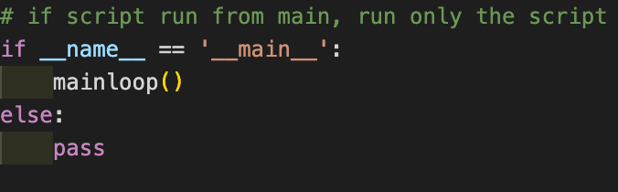

This code is used for the main menu, it will only run the main menu file and no other file unless explicitly stated.

I have used very similar variations of the code shown in all of the other python files with the same intended function, so I will not show them for the rest of the documentation.

### My Own Library

I will be creating my own library which includes frequently used tasks that I can’t easily find a prebuilt one from online. This will include button creation, text box creation and storing to and loading from json files.

I will be naming this file as ‘myLibrary.py’ and calling it into my code as ‘lib’ to use and read easily within the code.

#### Button class

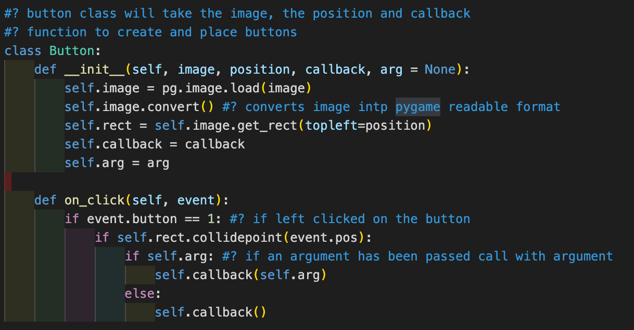

##### Function

This class will allow me to easily create a button in pygame and make it call back a function with it, something I will need on every page of the project with multiple instances on each page.

It will allow me to choose what image I want to use, providing it’s in png format, where to place the button with (x,y) coordinates and a callback function which allows for a single argument as well.

##### Parameters

|  |  |  |
| --- | --- | --- |
| Name | Function | Justification |
| image | Makes image, in png format, the interactable button that will be seen on screen | Makes creating buttons while coding the solution much easier and more readable for later development and for debugging |
| position | It takes an x and y coordinates in the form (x,y) | Makes the code more readable and easier to debug. |
| callback | Takes name of function and makes the button, when pressed, run the function | Makes the code more readable and easier to debug |
| arg | Optional argument, if function being called requires an argument, it will use what is ‘arg’ as the selected argument | Easier to debug and also easier to call functions within buttons in pygame |

##### Methods

|  |  |
| --- | --- |
| Name | Function |
| On_click | function to run when the user has clicked on the image |

##### jUSTIFICATION

The reason I have created a reusable button class in my own library is because it allows me to create multiple instances of this button throughout my program. I need this as multiple buttons will be needed on all the pages as that will be the only way the user can interact with the game. It will make me write less code throughout the program as I can import myLibrary into the python script, as I will not have to rewrite the class for every python script, every page, and use that one for the respective page. As I will be using multiple buttons, this code reduction is significant.

#### Input box class

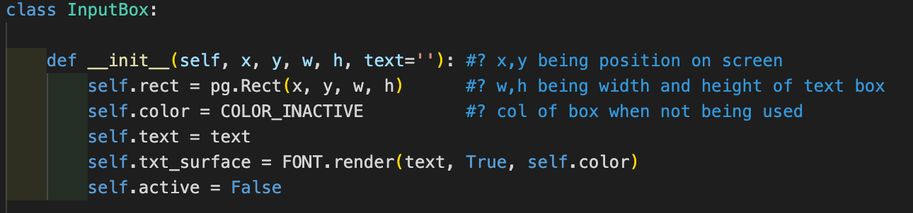

##### Function

Allows me to recreate text boxes within pygame very easily get the text inputed from the user from the text boxes

##### Parameters

|  |  |  |
| --- | --- | --- |
| Name | function | justification |
| x,y | Places text box at (x,y) pos on the screen | Easily manipulate the text box |
| W,h | Creates text box of width w and hight h | Easily define the text box size |
| text | Initially set to empty, allows for easy fetching of inputted text | Gets the text from the user very easily |

##### Methods

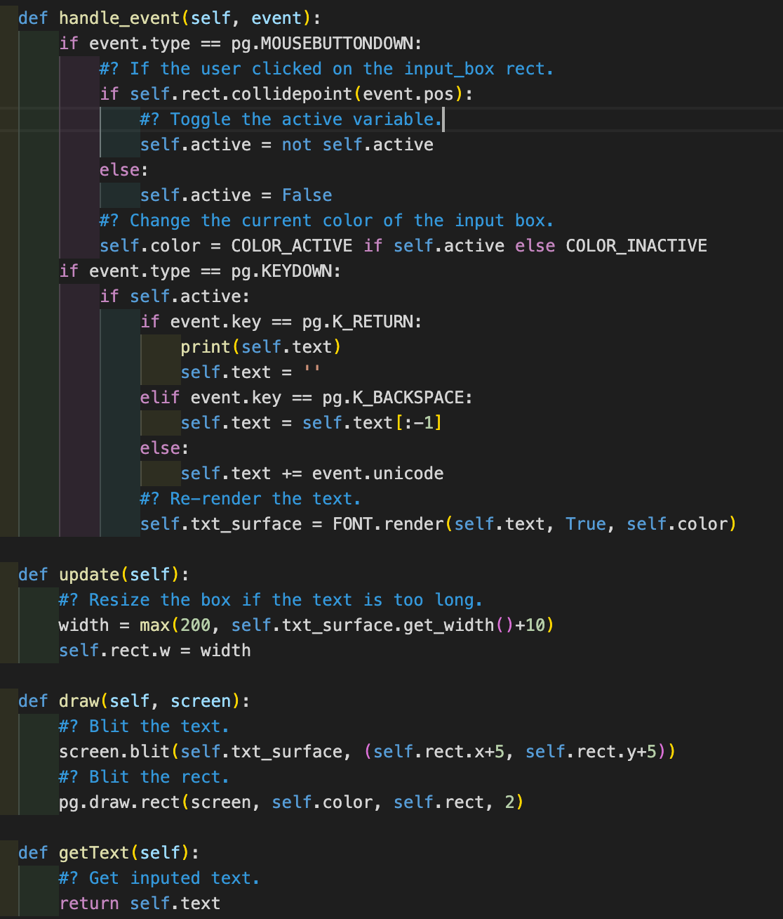

|  |  |
| --- | --- |
| name | function |
| Handle_event | makes it possible to type in the box when pressed, it stores the text being inputted then stores it in ‘text’ and when the screen is being refreshed it presents what is in the ‘text’ variable |
| update | If the text variable gets too long for the current text box, it will resize and make the new size to fit the longer text |
| draw | Presents the box on screen |
| getText | Returns what is in the text variable |

##### justification

I will be having an input text box for atleast 2 pages, the account page requiring an input for the country and the username and the board which requires an input box for the two users to talk to chat to eachother over the server while they are playing. Writing the input box as a class in the library means that I can reuse the same code for both the pages allowing me to write less code, rewrite the whole input box for both pages, so making the code more readable and easier to debug. Also if I needed to test the input box, I would not have to test the input box for each page separately, this makes testing easier as I can just test this class which therefore tests the code for multiple pages’ functionality.

#### Json functions

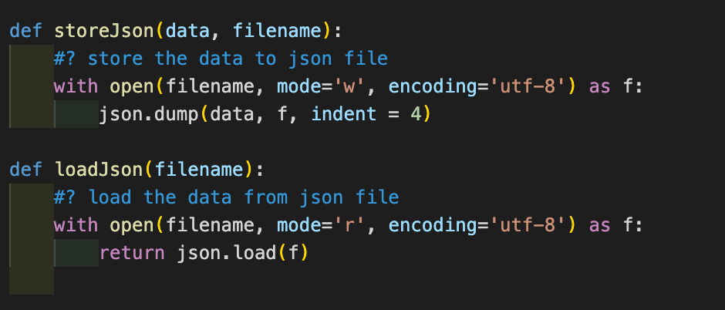

##### Function

This will allow me to easily store and load json file within the code.

##### Parameters

|  |  |
| --- | --- |
| name | function |
| data | The stores the data into the file |
| filename | Stores/loads the correct json file |

##### JUSTIFICATION

Creating the fetch and store data from json as a function in the library is beneficial as I will be fetching and storing data multiple times in many pages.

The reason it’s a function is because I will be calling and storing data multiple times in a single python script, so being able to use a function for this is beneficial as I will not have to rewrite the code for storing and calling json data in the python multiple times. This makes the code easier to read and easier to debug in the future as there will be less repeated code in the codebase. I will also be using different json files, so creating a generalisation for this is useful as this can be used in more than 2 json files, the json file title being an input.

The functions being in the library is good as I will be calling and writing to json files in multiple pages, different python scripts, so I can reuse the same piece of code across multiple scripts easily without needing to rewrite the functions.

### Main Menu Page

#### FunctioText Description automatically generatedns

These functions are used to be able to run the other pages from the file, so the user can access all the pages required to play the game, and the quit button

The code for each page that handles the operations that take place when the user interacts with the program is in a ‘mainloop’ function which runs the page generation and all the actions needed for the respective page, we call the function instead of calling the script directly.

This is done as it is easier to manipulate when coding the solution and that calling the whole script directly causes errors within pygame as pygame will try to run the code designed for another page on the currently running page. When running the settings page from main menu, pygame will try to set up the settings page in the main menu window instead of creating a new one. Calling functions within the scripts solves this problem.

#### Loading images/buttons and the window

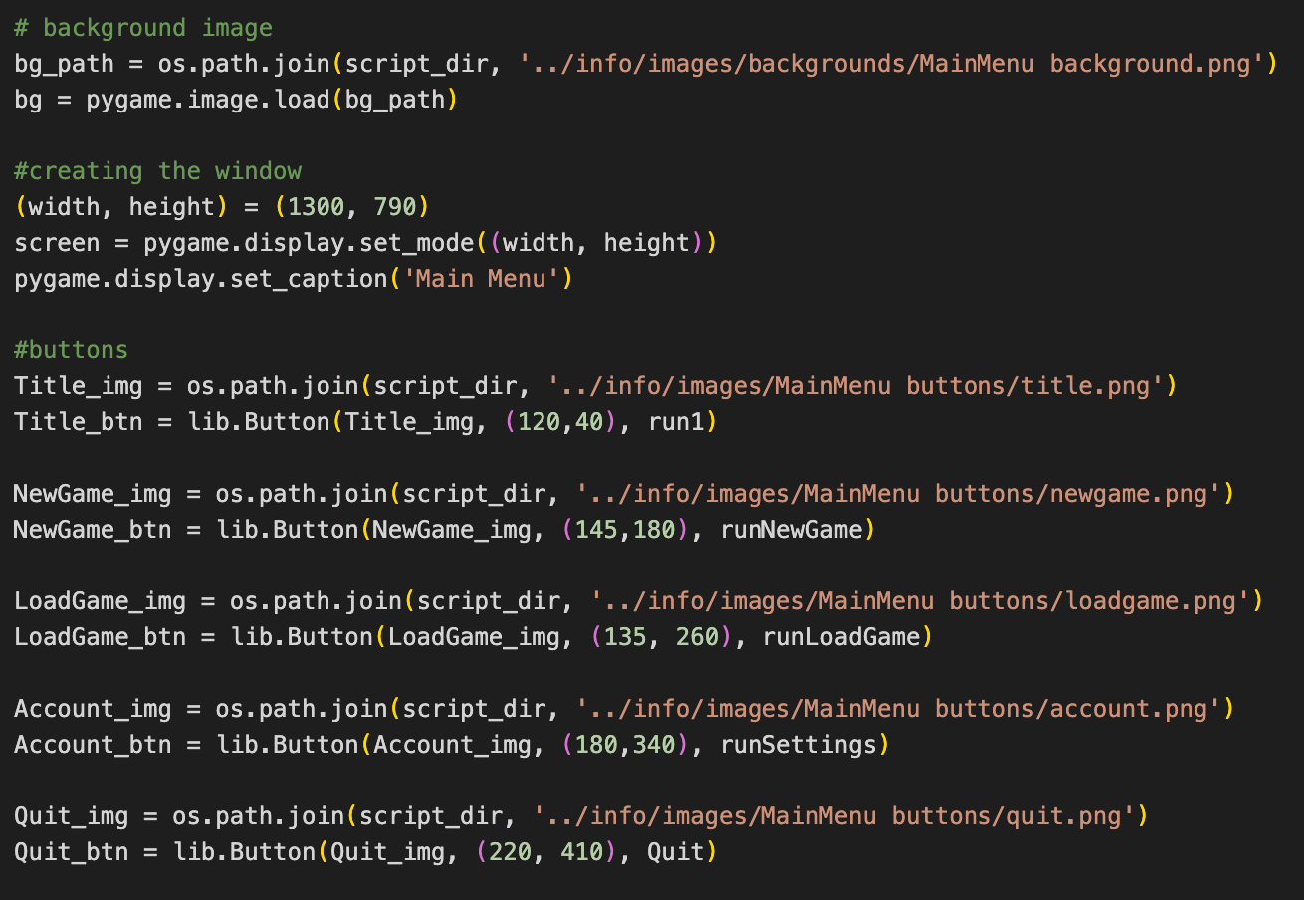

This is where I have loaded all the images needed for the window, put in their coordinates, and created them into a button. Each button has an image and their button surface counterpart, I will blits the button on to th screen, which separated loading the button and creating the button itself.

I have loaded all the images for the main menu page from the images folder and from the main menu buttons folder, as discussed in the design section. I have used my own button class to be able to create buttons easily and quickly.

Each button runs its respective function to be able to present the user with the correct page.

#### The Main Mainloop Function

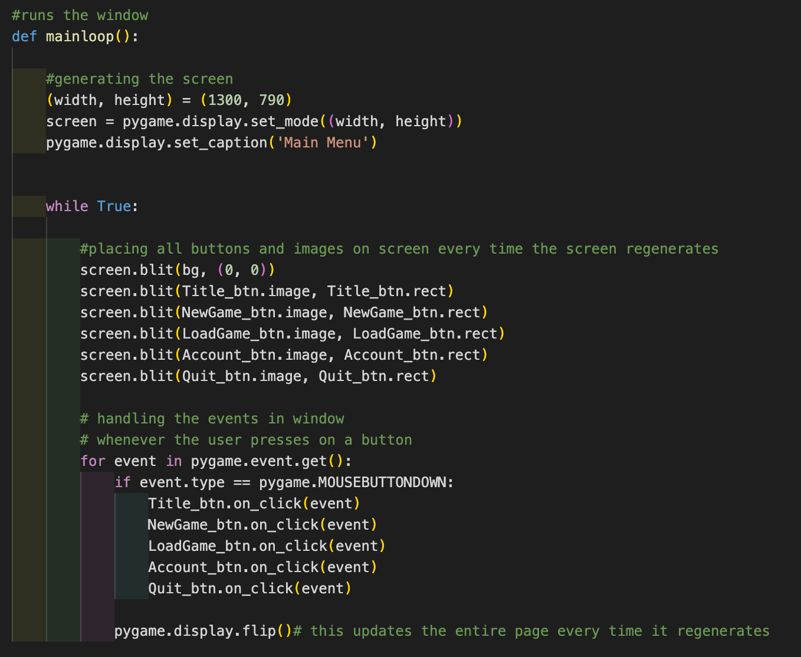

this is the function that runs the page itself. Everything outside of the while loop is constant within the page. I have defined the size of the window, placed the window on screen and named the window ‘main menu’. This is required for every page that is created in pygame.

Within the while loop is where the page is constantly being checked for any events and where all the buttons/images get renewed every time the page regenerates. I have places all of the buttons on to the screen allowing the user to see them, including the background image.

The for loop checks for the actual button presses. It loops through all the buttons and checks of they have been pressed, if the user has pressed down while the mouse is within the image dimensions of the button, and if so it runs the respective function to call the new page.

At the end of the for loop, the ‘pygame.display.flip()’ updates the contents of the entire page, so when the while loop is next run, it will present the user with the new appended page based on their interaction with the page.

##### justification

The reason the code for the main menu window itself is in the mainloop function is because other python scripts will need to run the main menu page. It being in a function allows for the other scripts to call the important parts of the main menu page and run it on command.

We will need to import this page to be able to run it in another script. When we import it, python runs the code instantly, directly after importing it. To bypass this we can put the relevant parts of the main menu page into a mainloop function so we can easily call the page.

### Settings Page

#### Music Options and libraries from Pygame

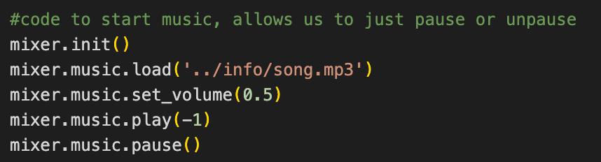

I have used pygame to be able to play sound in the background of the game. I have initialised it and set it off to begin with by writing ‘mixer.music.pause()’ at the end.

##### The buttons for music

i have decided to use 2 separate buttons for on/off music option as explained in the design. Here im defining the buttons

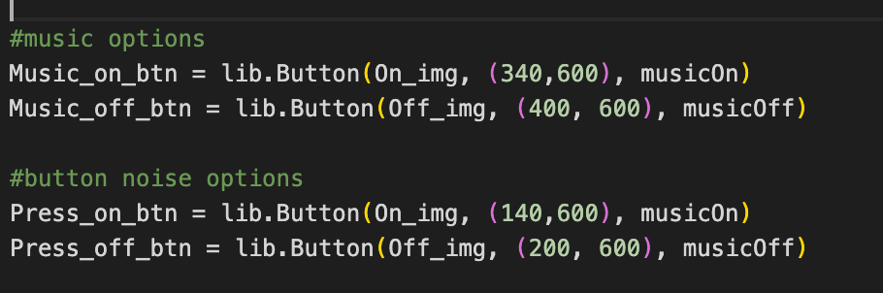

I then blits the buttons on screen and allow for the events of each button to run when clicked on within the event loop

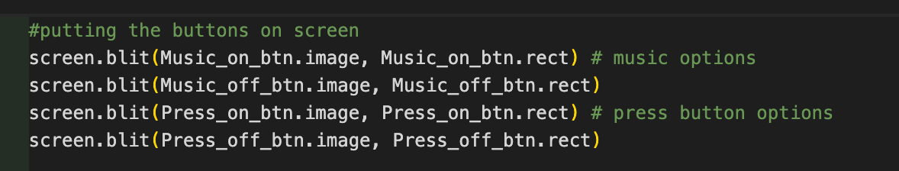

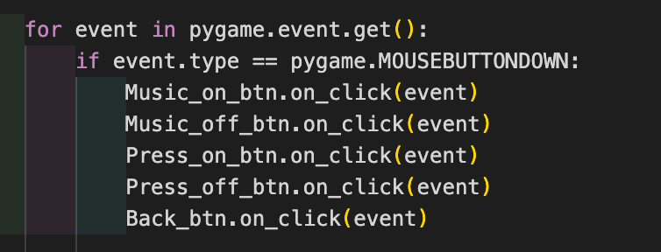

#### Implementing the icon selection

There was two ways I could’ve implemented this. I either created a dictionary outside the mainloop of the page that stored the current state, whether it has been picked or not, of the icon or I directly read and write to a json file that contains all of the current states of the icons.

I decided to use the dictionary method as it is quicker for the user to run and also allows me to store all of the users features easier as I would be able to read from the file easier later on in the development. It is also easier to debug as even though there is going to be more code to write, it will be easier to understand and follow the logic rather than using the json files.

##### The dictionary method

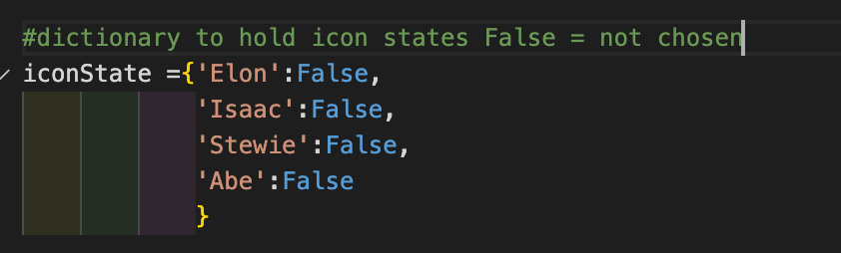Initially I set up the dictionary containing all the icons names with a Boolean value indicating whether they have been chosen

This is created outside of the main while loop of the page as we will read from it during the while loop allowing us to know which character was chosen or not, letting us present it to the user.

###### Getting preselected icons from json

If there was already a preselected icon from the user, instead of keeping them all false, we will change the one that he has chosen to true by checking this before the main while loop also.

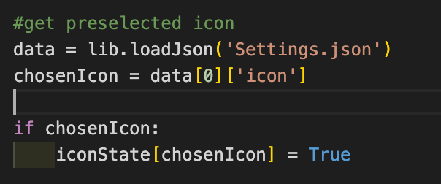

###### Function to select and deselect

Each icon button must run the same process to make sure that all of the other options are turned off and that the selected one is turn on to make sure that the user cannot appear to choose more than one option.

There is a function that each icon button runs to ensure that it is the only one that is the only one turned on. it takes the icons name as a parameter to make sure it turns on the right icon. It loops through all the options within the dictionary and makes all the icons false except for the icon selected and makes that true

After it has done that, it stores the chosen icon in a json file which contains all the user’s data inputted into the settings file.

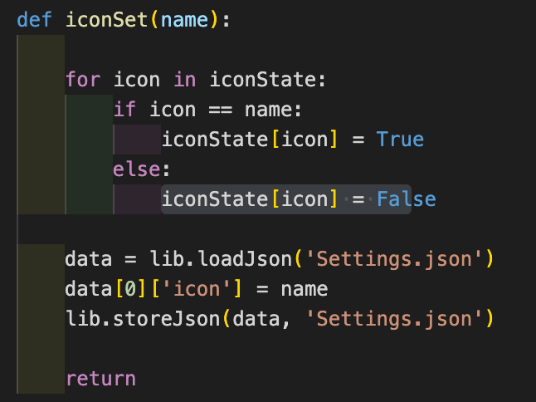

###### Setting up the icon buttons

Here I have just created the on/off buttons for each icon. Their call back function is the iconSet function with their label as the parameter. The off button has the icon with the red circle around it and the on button has the icon with the green button

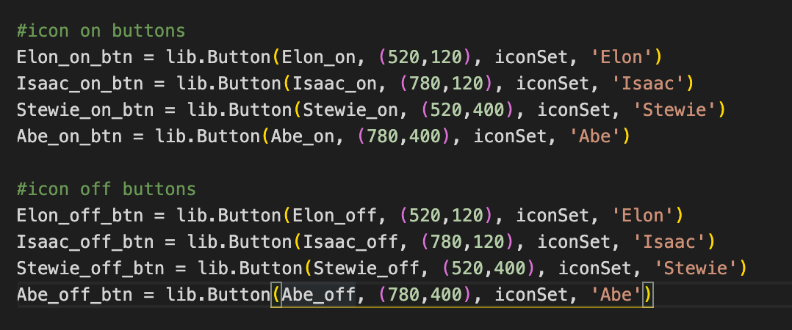

###### Getting Right Image and Blitsing it on Screen

Here I am going to find a way to select the right image, whether it is the on or off version, of the icons and make sure they change accordingly to user input

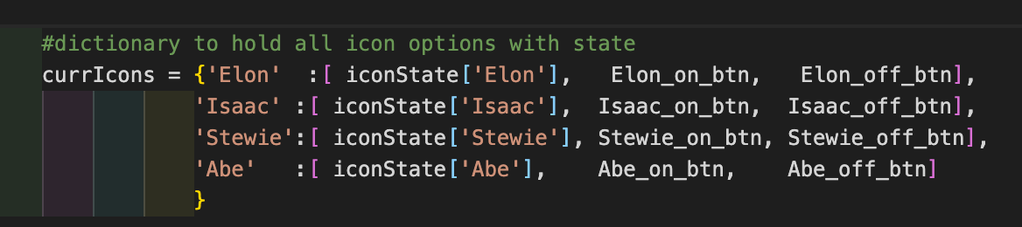Within the while loop of the page, the section that keeps on regenerating the page, I will create a dictionary that holds the state of each button, fetched from the iconState dictionary, and both variations of the button, on and off, for each icon. This will be used to determine which type of button to use on the page in real time, so it must be in the while loop.

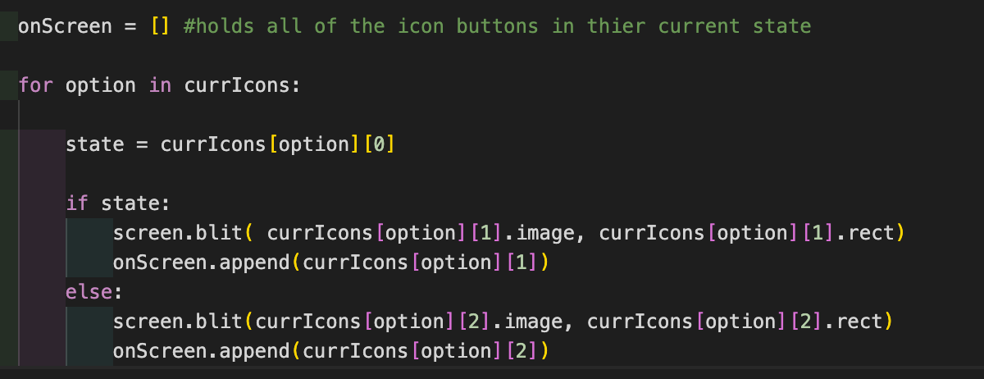Then we will loop through this dictionary finding out which button to use, based on the iconState variable, and blits it on screen. Then we will put the respective button in an array so when we check for events on the page, we can call its function by looping through the array, not needing to write out all of the button states one by one. It is in a dictionary because this will be easier to fetch the relevant pieces of information from the dictionary rather than calling each separate variable with selection statements depending on the input. This will allow me to write more generalised code.

Within the event checking loop we will loop through the onscreen array and call the function of each respective button if clicked

#### Getting and placing all the images on screen

This is just getting all the non button images from the file and placing them on screen, I call these labels

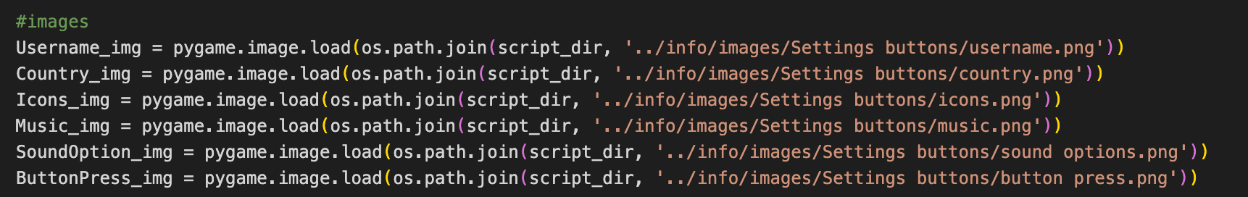

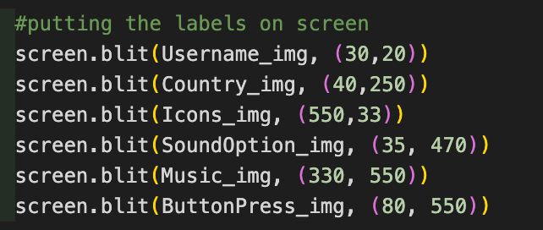Here is placing them on screen within the while loop in their respective coordinates

#### Implementing the input text boxes

The solution uses the same logic for username and country, so I have places them close to each other in the code to make the code more readable

##### Getting previous inputs

Before I blitz the boxes on screen, I first check the json file if the user has previously entered a country and a username and use those if they have stored any

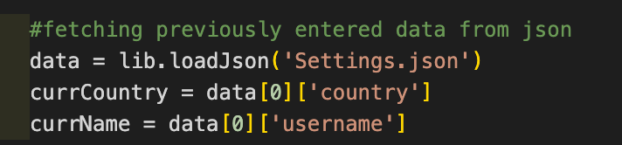

##### creating the boxes and storing and placing the boxe inputs

Here I create the buttons using the predefined box class from myLibrary and place them on screen in the while loop, placing the recently inputted text inside the box at parameters to the class

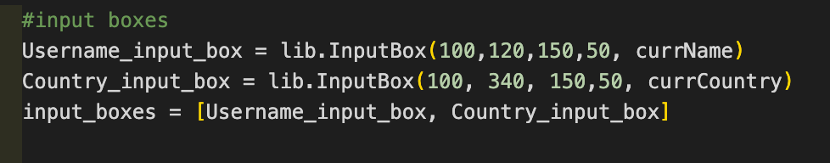  
I then store the text inputted into the boxes after every regeneration of the page, within the while loop, in json.

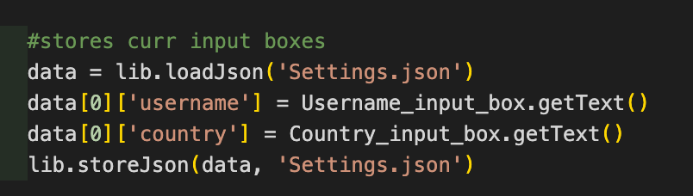

Within the events loop for pygame, I take both boxes and allow the user to input text into it. So, it runs the call-back function for the input box when it is pressed

Then I redraw the boxes with the new text that has been inputted into them

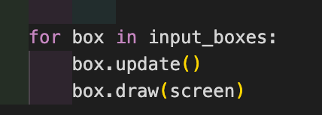

### Implementing the new game page

#### The Functions Needed

Here are all the functions I will be using throughout the code for the page.

##### CHOOSING BOARD SIZE BUTTONS

This function has the task of setting all the button states as off, showing them as grey to the user, except for the one he has pressed, making that red. If the user has double pressed on a button, he then turns it back off, so it turns grey again, changing the status of the button. It takes a parameter that is the name of the button that has been pressed.

It does this by getting the dictionary, optionChosen, looping through all the options and if the option is the option chosen, it sets it as the opposite of what its current state is, allowing the user to turn it off and on as they wish. If it is not the button pressed, it turns all of the other options off, false making them turn grey, so if the user presses one button, then another it is not possible to have both board sizes on at the same time.

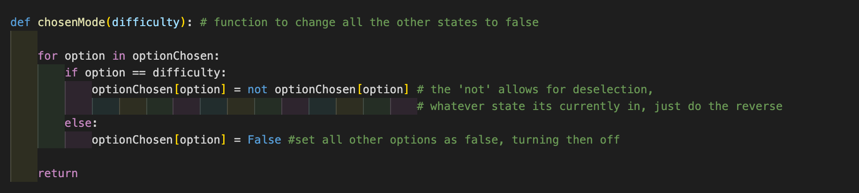

##### Run the board game with size

I have not yet filled this function with the necessary requirements and code as it is dependent on other parts of the development stage which I have not gotten to yet.

This function will carry out the task of calling the board script and running the search for a partner who has chosen the same size board as the user to play with. It takes the size of the board as a parameter and feeds that into the other partner finding script so it can see if anyone has chosen the same size board. This will be called when the ‘go’ button is pressed.

#### Setting up images and button and variables needed

##### Setting up ther background and window size

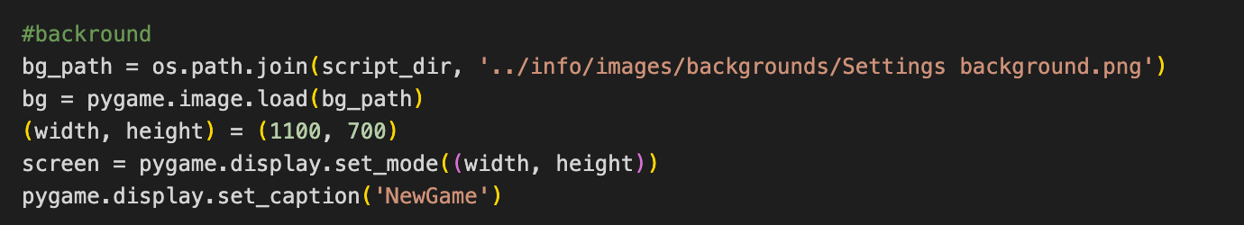

##### getting button images and making them buttons

Here to be able to import images for buttons, I must import them using the os way rather than making them use pygame as my button class does not work when using a pygame surface.

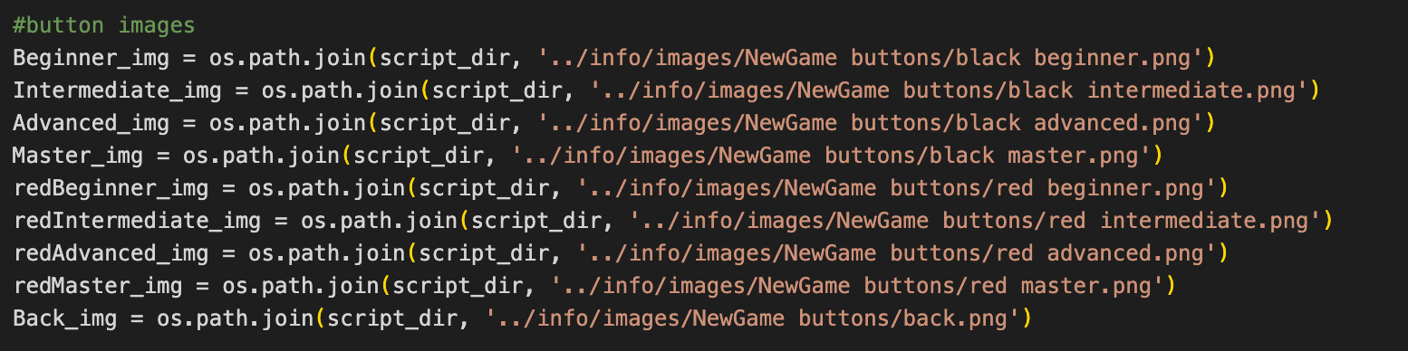

Here I’m making instances of the button class with the images with their respective call back functions and inputs

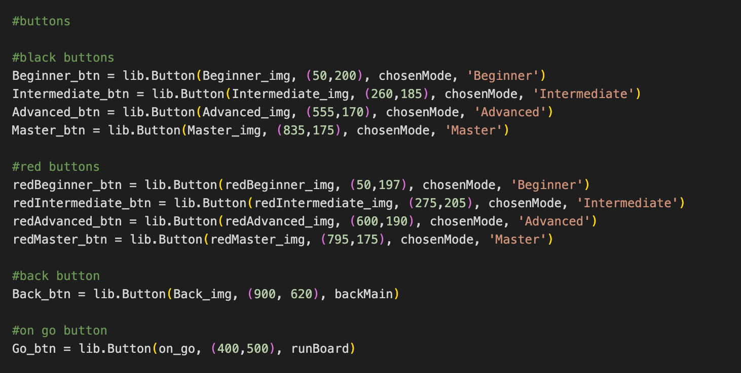

##### CREATING IMAGES WITH NO FUNCTION

Here are all the images being imported that do not carry a use, so they will stay as images. I can import them with the more flexible pygame library method.

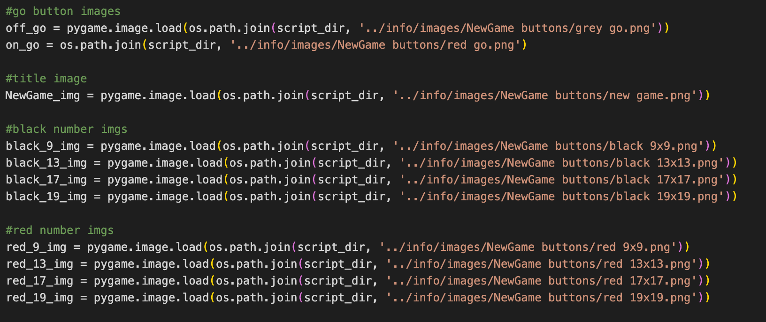

##### holding current state of the buttons

I have used a dictionary outside of the main function as this must not change with every regeneration of the page as it depends on the users’ actions. Therefore, it must stay outside of the page generating function and keep its contents even after the page regenerates as it is not dependant on the page activating, only user input.

This dictionary holds the title of every board size option with its current state on or off, initially being all off. It will be changed when the user presses a button so when the page regenerates it can fetch the correct status of the button.

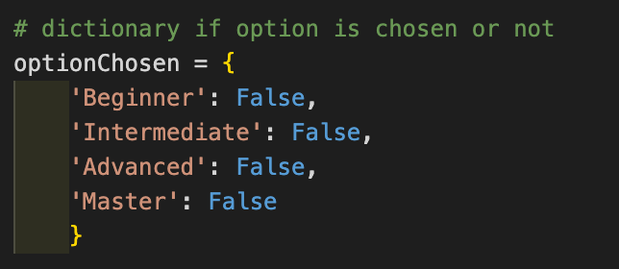

#### The Page Creation Function

I have used a large function called mainloop to hold the activation of the page as it allows me to call the function in other scripts while not crashing.

The mainloop function just contains the while loop regenerating the page continuously, so I will be explaining what is within the while loop making the page run.

##### handling the optionS STATES

I have used a dictionary to be able to store all the images, buttons and current state of all the options, allowing me to easily access all the required elements of each option when required.

I have called the optionState dictionary to get all the current states of each option. This must be done every time the page gets redrawn as this will change when the user presses on a button.

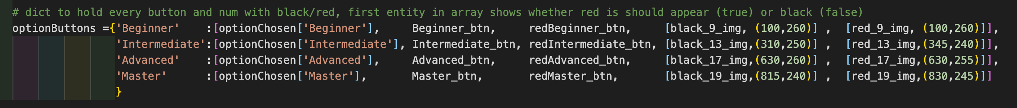

I have stored the state of the option allowing me to know whether I should be displaying the black option button and the black numbers, or if I should show the red button option with the red numbers. I have separated the numbers and the text as it looks much better and allows me to recentre the numbers to the correct size independent of the text. This is because when screen shotting the images for the whole button, including the image, the numbers would scale up/down with the buttons when trying to place them appropriately on the screen, making the numbers unreadable and out of place

Each number image has their respective coordinates in the same array as each other, this is because when I will be blits them on screen, I can easily find out where then should be placed.

##### PROCESSING THE OPTIONS and correct display

To display the correct buttons, I used an array for the button and the numbers so I can loop through them when I need to blits them on to the screen and allowing me to handle the events for each button.

There is an ifChosen variable, this presents the go match making button. I used a variable and displayed the go button separately to the while loop as there is only going to be one on button, therefore placing the logic into the while loop would mean the off button would be run at least 3 times, thus making them overlap each other on screen which would be incorrect. This also makes the code more readable.

We loop through the optionButtons dictionary and check if they have been chosen or not. If so, we choose the correct colour buttons to and numbers to append to the array.

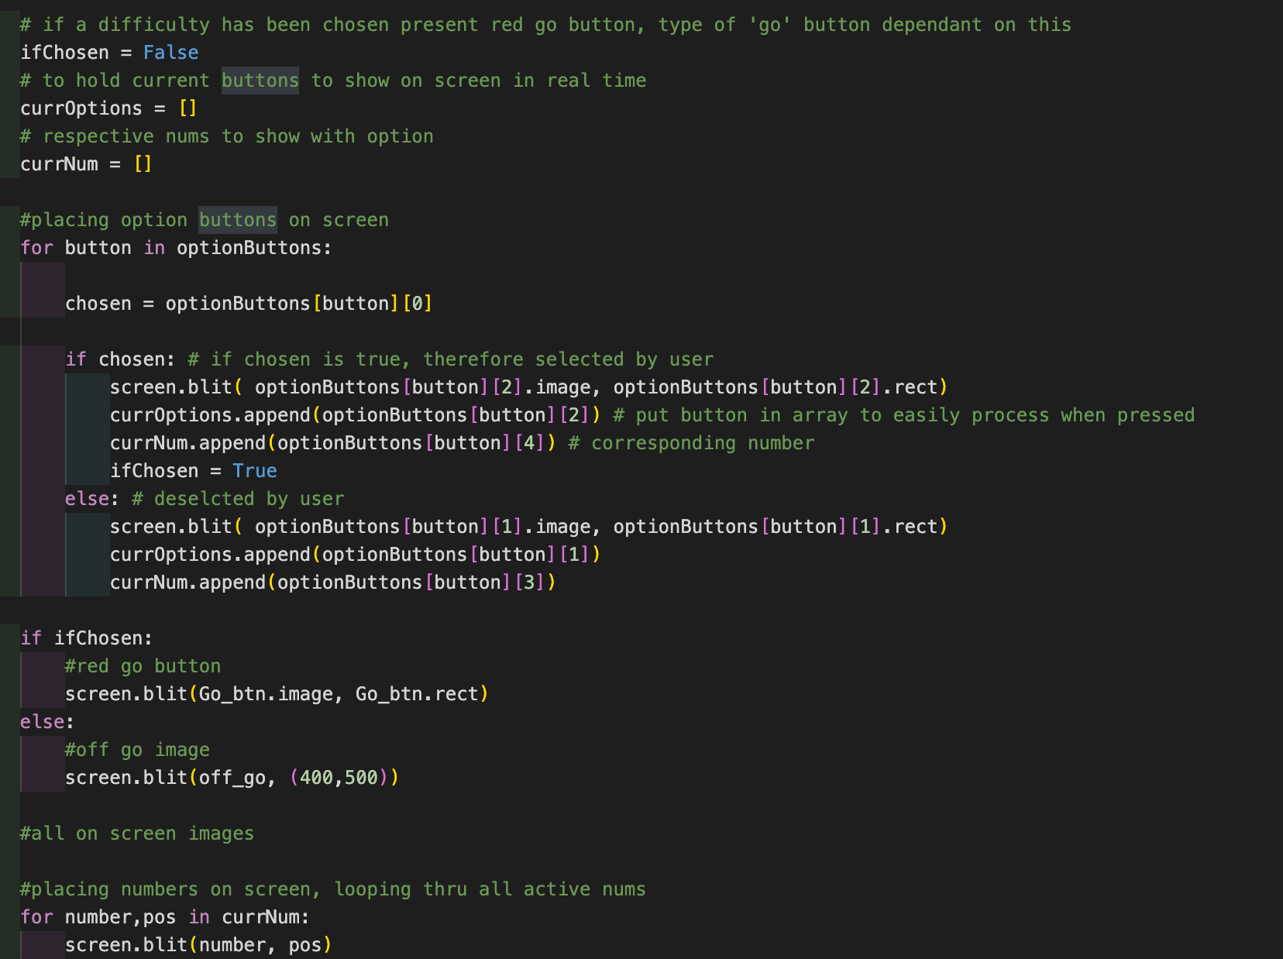

##### BUTTON EVENT HANDLING

This loop goes through all the option buttons, back button and if there is a ready go button, the go button. Making sure when they are pressed, they call their respective functions

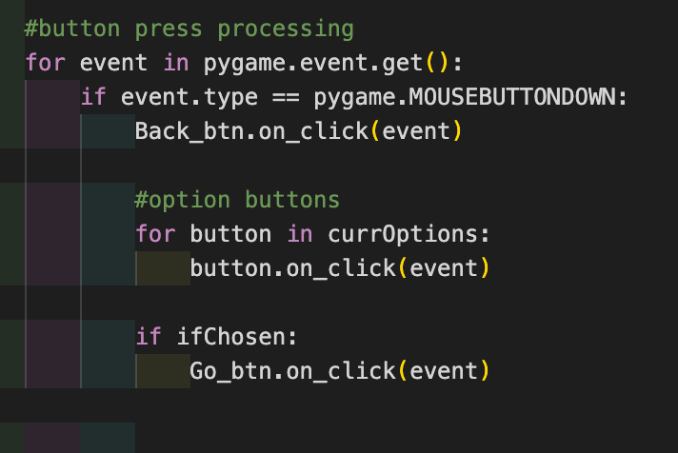

### Implementing load game page

This page will allow the user to run and open previously saved games.

#### Functions Needed

##### Run game

I haven’t implemented the functionality of this function yet as this requires me to open previously saved games from a json file that I have not created yet.

This function will take in the game id as a parameter and feed it into the board file page where this will load in all the content of the previous game and go back to where the user has left it.

This will be called when the user presses ‘go’ on a saved game, so each button for a new game must be created to allow the program to read the information of each game.

##### Back main

This is for the back button, when it is pressed will take the user back to the main menu

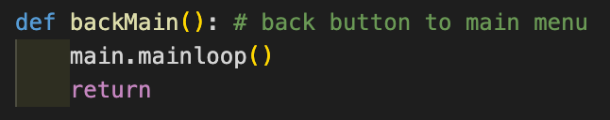

#### Setting up Images, Button and Variables

##### INITialisations

Here I have set up file path, the pygame page initialisation and the font I will be using in the page from pygame

I have also set up a constant for the distance between each new game button

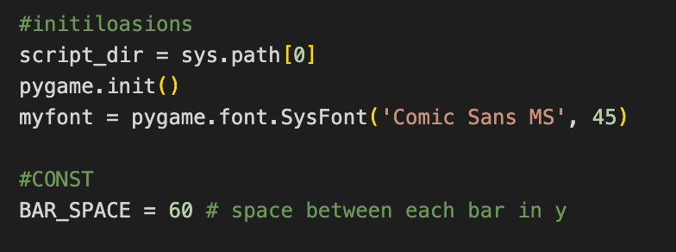

##### Getting images

Here I have gotten all the images from the loadGame buttons file and opened them with pygame as it is easier to manipulate them later on

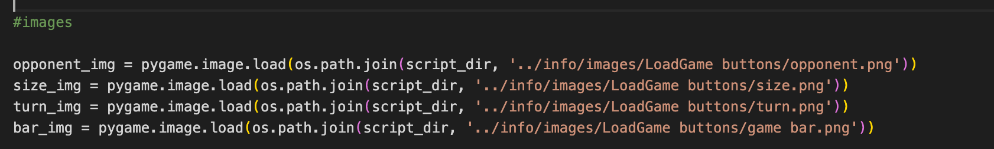

##### getting images for buttons

For buttons I have used the python os library to get these as the button class I am using doesn’t take pygame surfaces to create buttons

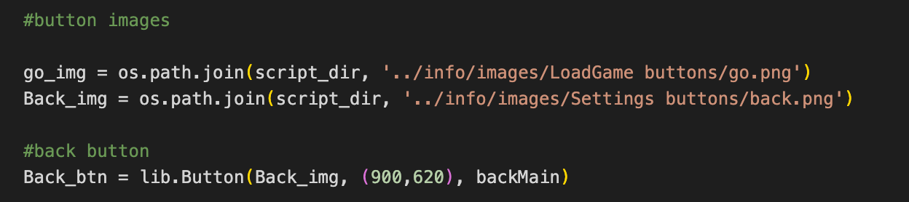

##### Getting and manipulating the saved games from json

I initially collect all of the data from the json file savedGames, the amount of games there are and create an array, gameInfo, to hold the relevant information needed for this page, opponent, size of board and who’s turn it is.

Then we check if there is more than 0 games, if so we collect the information of each variable and store them in a 2d array, so each row holds the game info for one game.

This lets me create the buttons for each game easier as I can create them in games instead of separate variables

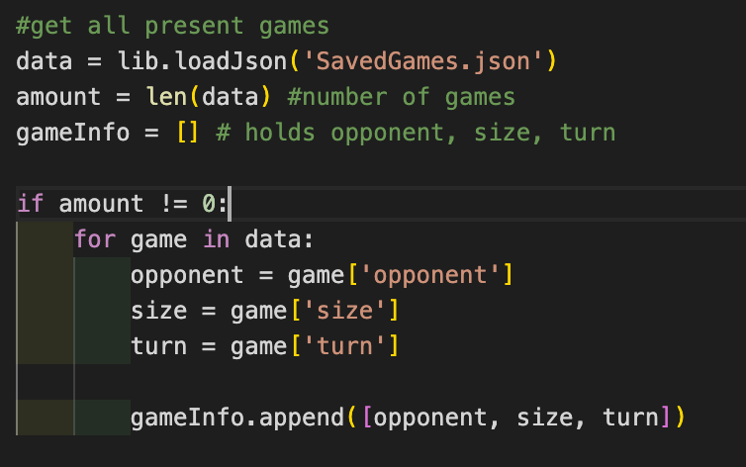

##### CREATING the text for each game

Here I loop through each game in the gameInfo array and create the text required for each word using pygame font.render() function and store each games text in an array called labels.

The render method takes the rgb values of the text you want to display and the string itself

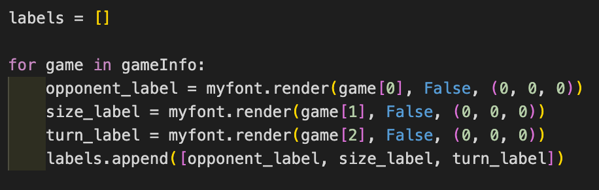

Then I create the go button for each game and calculate the position of the new position of each button and store it in an array called go buttons. Esch go button has a call back function that runs the game and a parameter for the number of the game it is, so we can get the information and load the right game

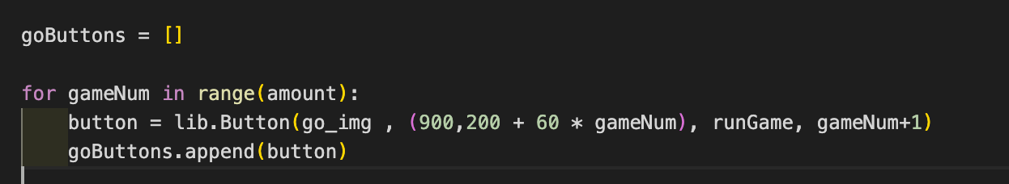

#### Page creation function

##### screen generation

Before we enter the window loop, we set up the screen size and window. This must be in the function as when we call the function it must create the page to allow all the other images and buttons to be placed on there

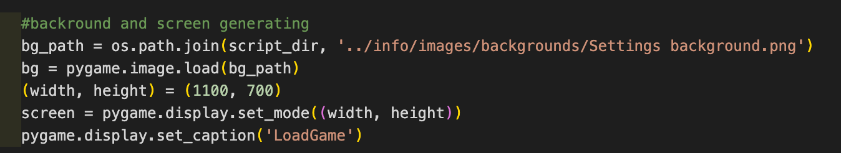

##### BLITSING THE IMAGES IN SCREEN

Inside the window generating loop, the while loop, I have insitally places the images on screen

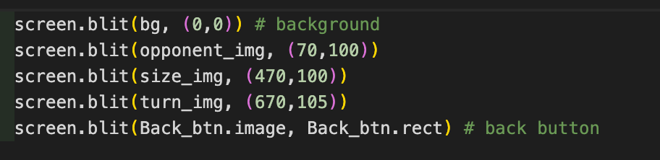

##### placing the bar image for each new game on screen

Here Im placing the bar image on screen and calculating the new place I should place the bar each time

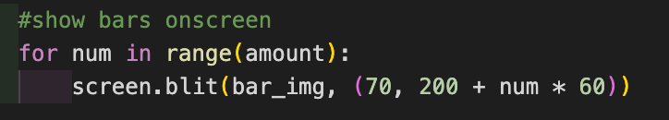

##### placing text and go button for each game

Here Im looping through each game and placing its information on screen, on top of the bar. Im also placing the go button for each game on screen   
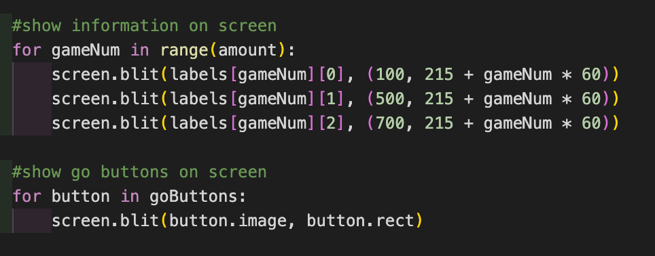

##### event handling loop

Here I’m checking if the back button has been pressed and of any of the go buttons for each game has been pressed, if so run their respecting call back functions

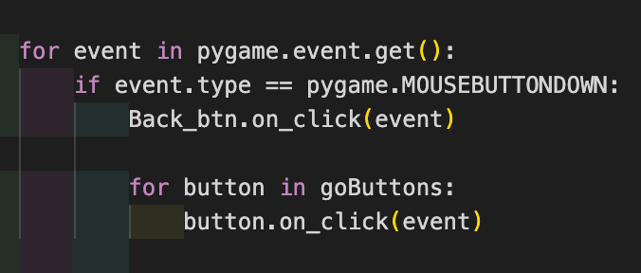

### Testing prototype one with user feedback

#### Testing on Users

I have created a survey using google forms and have sent out my first prototype to users to test and respond so I can see what their opinions on the first prototype is and if I should make any changes. It was very successful, and I got 3 responses.

##### The form

I have asked the users to create a new game, load a new game and create an account and rate them on their difficulty and explain anything else they would like to add to change the game

[The form](https://docs.google.com/forms/d/e/1FAIpQLScMd5MH2RbFY6I7GfYnkb3qGCyhcf1W3MXxnCrtVQa9vaWHYg/viewform?usp=sf_link)

##### THE RESULTS

###### Account Page

Here I asked users how hard it was to navigate the account page and if they had any ideas for improvement

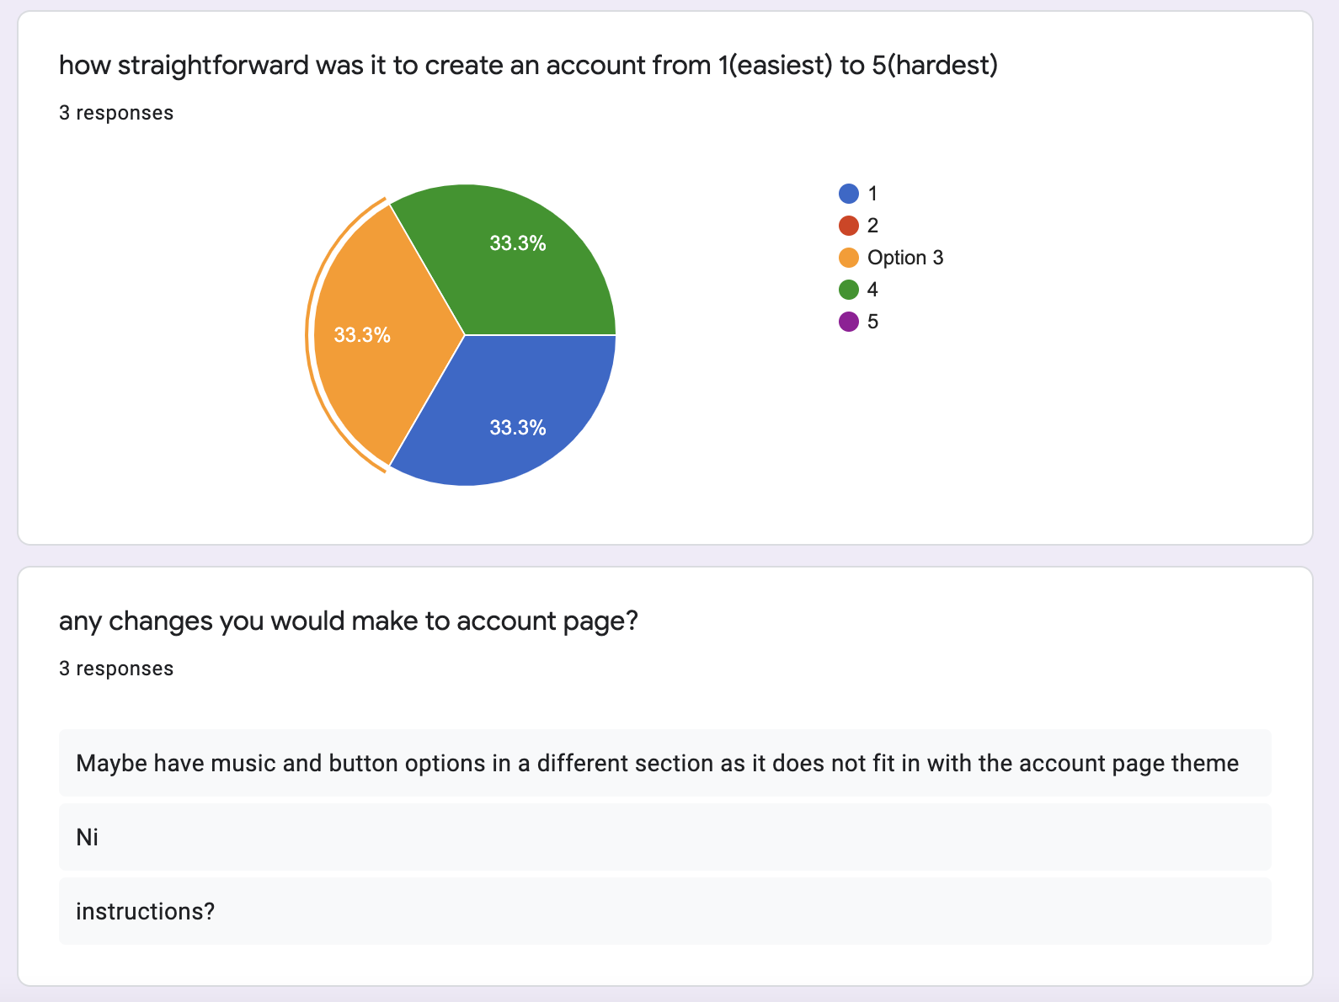

It was generally deemed easy to navigate, however one user asked for instructions. This is a very good idea and clearly needed, i will include instructions to my account page.

Another user asked for the sound options to be placed somewhere else in the program as it did not fit with the theme of the account page. This is a sound issue, however there is no other obvious place to put the sound options as it would not fit with the theme of the load game or the new game page, so I think I will leave it in the account page.

###### New Game Page

Here I asked users how hard navigating the new games page is and if they had any ideas for improvement

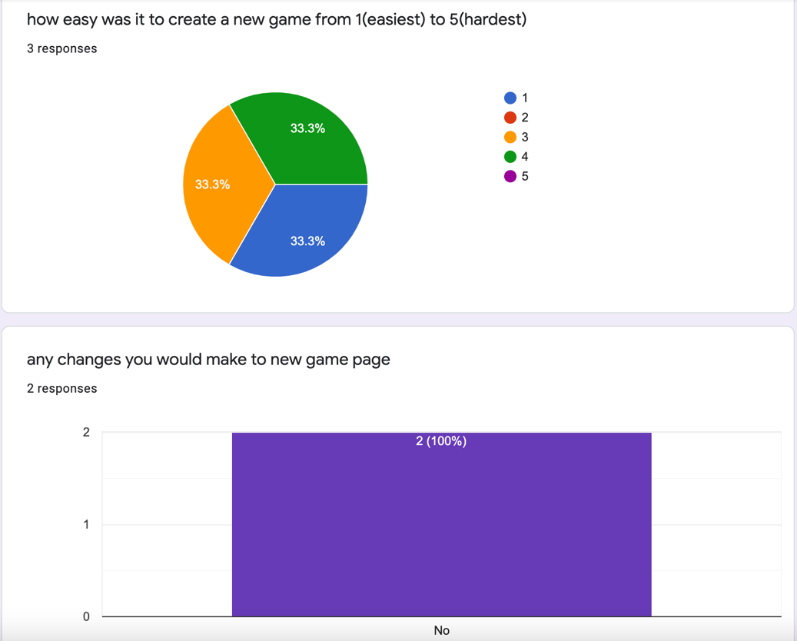

It was generally found that using the new games page was easy which is good. There was nothing that the users thought should be improved about the new games page.

###### Load Game Page

Here I asked users how hard navigating the new games page is and if they had any ideas for improvement

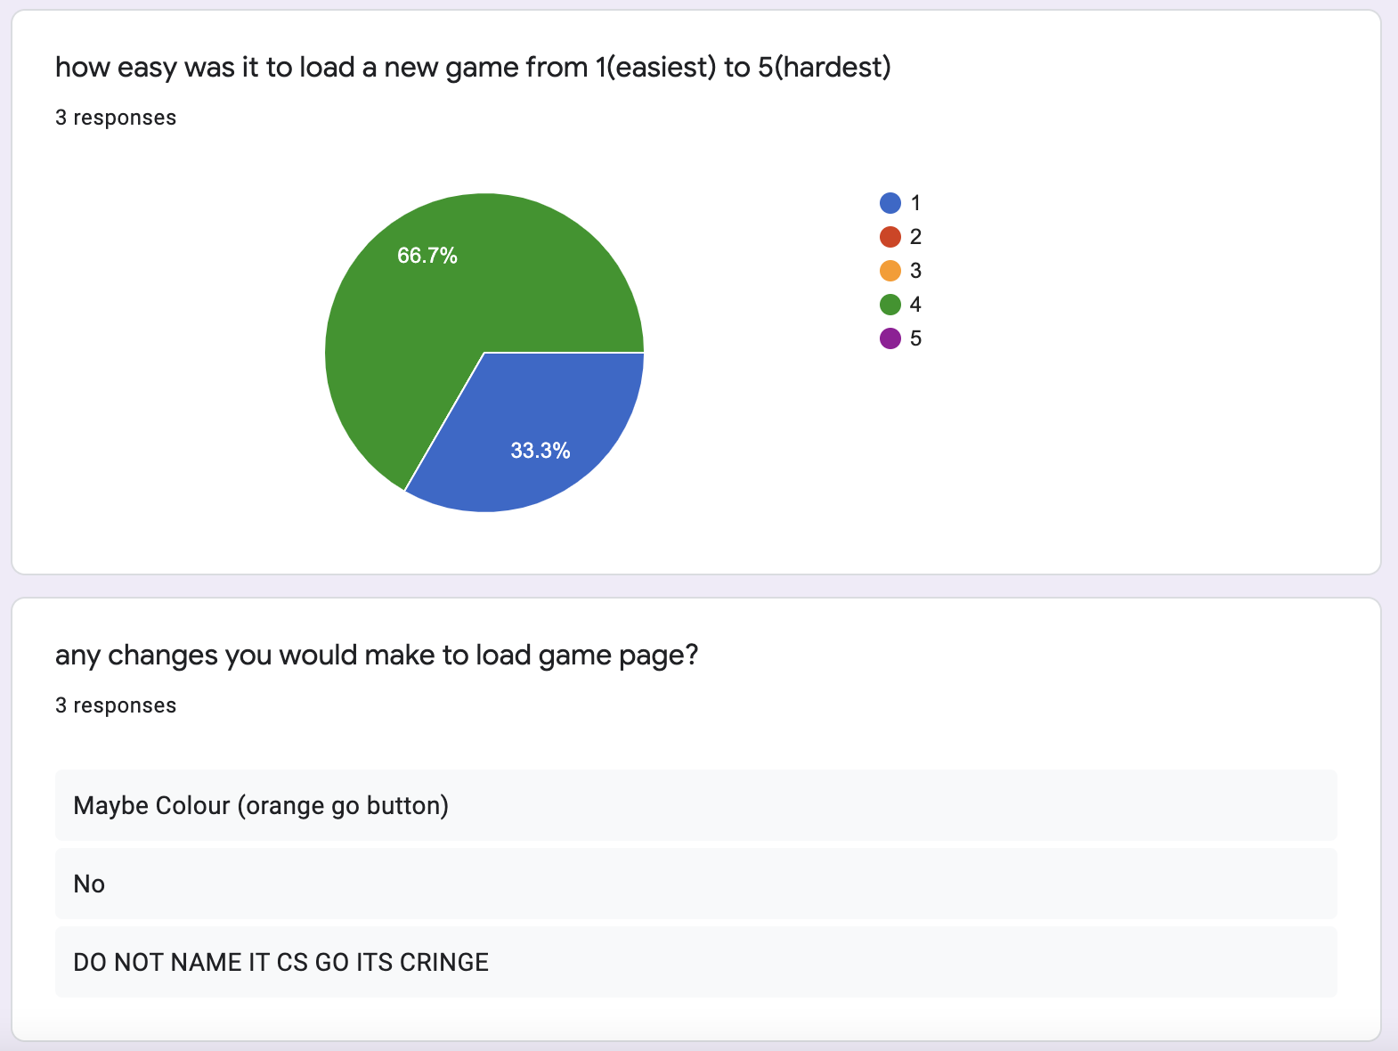

The uses seemed to have had difficulty navigating the load game page as 67% said it was a 4 or higher. It is unfortunate that there was no constructive feedback about why it was difficult to do so, so I will be unable to implement a solution to this.

Here I will be creating an enhanced account page as i will have to add an instructions

###### General improvements to the solution

Here I asked users if they had any ideas that would improve the first prototype that I have not included

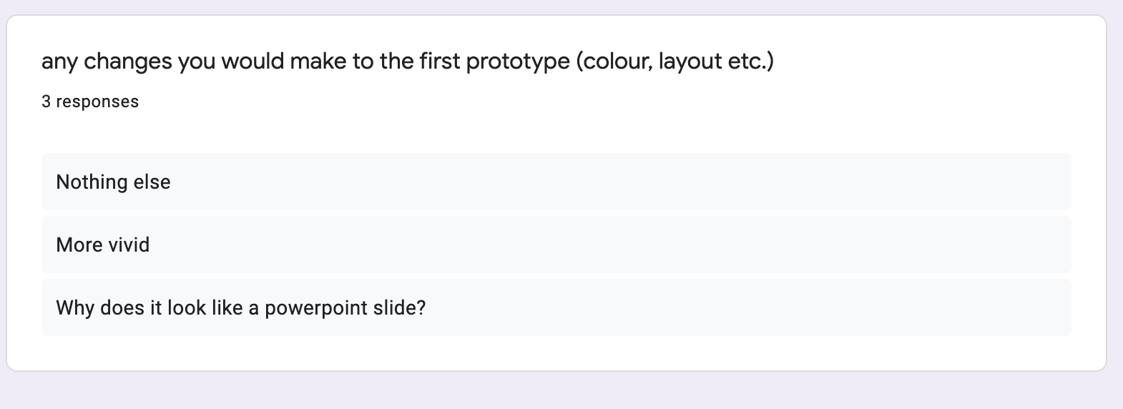

The users either said that they had nothing else to add or did not add any useful constructive feedback that I would be able to act upon, therefore leading me to assuke it was ok.

#### Implementing feedback from users

As mentioned, one user said that they would like to see some instructions in the account page, here I will design and implement instructions on the accounts page.

##### design

The aim of this implementation is to try and make the instruction on the accounts page subtle and discrete, not distracting the user from the main features of the page but to aid it.

## Prototype 2

In this prototype I will be creating the board game page, adding game logic

### Creating The Board

#### Libraries needed

I will use the same libraries as before, however here I will also be using the copy inbuilt library in python. This will allow me to create a deep copy of the current board state so I can run the recursive bfs algorithm and edit the deep copy board without affecting the original board

The reason I need the inbuilt copy library is because while I was processing the board to find if any current positions are not being used now. As this algorithm is altering the board, it must not alter the original board that is being used to present the board to the users as if it were to use the current board the users would get a different, incorrect, board which they will therefore not be able to play the game.

When editing the deepcopy it doesn’t impact the original board

#### Functions Needed

##### CHECK IF a stone has been captured

Here we check if a stone has been captured or not. I will be using a flood fill/bfs algorithm where we are checking directly surrounding current stones area until we either meet a free position, which means it is not surrounded, as the rules of go dictate, or we are out of bounds.

I have coded this by recursively calling a bfs algorithm on the position, then to its neighbouring 4 directional positions. If the position next to it is a free spot, then it is automatically or if it is out of bounds, we end end the function and therefore set ifSafe to true as the current stone is not captured. If the current stone is the players stone, we set that position equal to -1 as we have now checked this position and will not go over it again, and recurse over all its neighbouring positions.

We have not explicitly checked if the stone is the opponent’s stone. This is because this can be handled by not recursing over that position as it is not a free space or empty, so it helps us define a boundary.

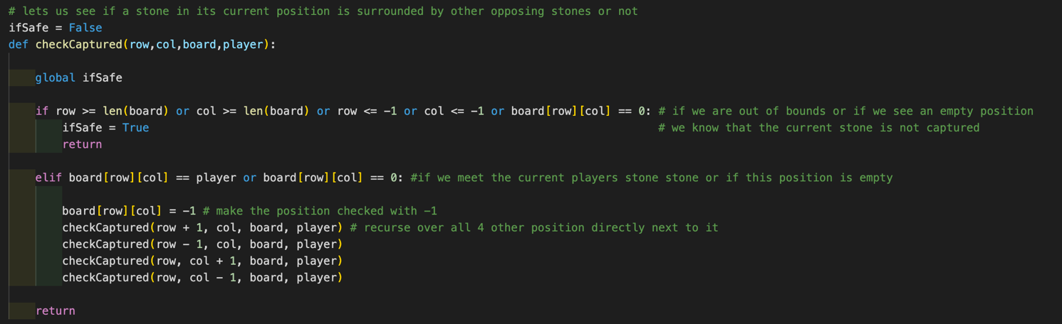

##### PLace stone function

This function will allow the user to place a legal stone on the board by checking if the current position is empty. Only if it is empty, not already captured or taken, can the user place their stone there.

The way we make sure the user is allowed to choose a new position is by using a turn counter. This keeps track how many moves have taken place. As Go is a 2 player game that only lets the players make one move a turn then alternates, I can set the turn variable to 0 initially and check if the turn variable is either even or odd. If even that means it is the first players turn, else it means it is the second players turn. It counts the number of moves indefinitely until the game is over.

I also use an ifMoved variable which is initially false, turned to True when there is a valid move made. I use this to allow me to know when I should run the checkCaptured function. It is set back to false after the checkCaptured function has been called and has fully terminated

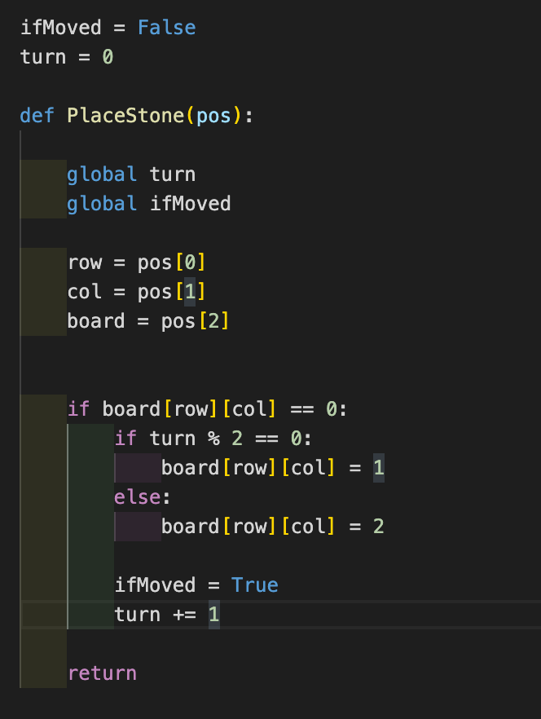

#### Images, Buttons, and processing Variables

##### LOADING IMAGES NEEDED FOR THE BOARD

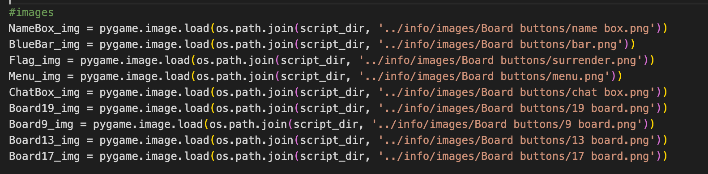

##### loading icon images



##### loading images of the stones

Here I have loaded each stone, black and white, for each board size I had to manually change the sizes of the images of the stones to match the size of the board. So there are a pair of stpones for each board size

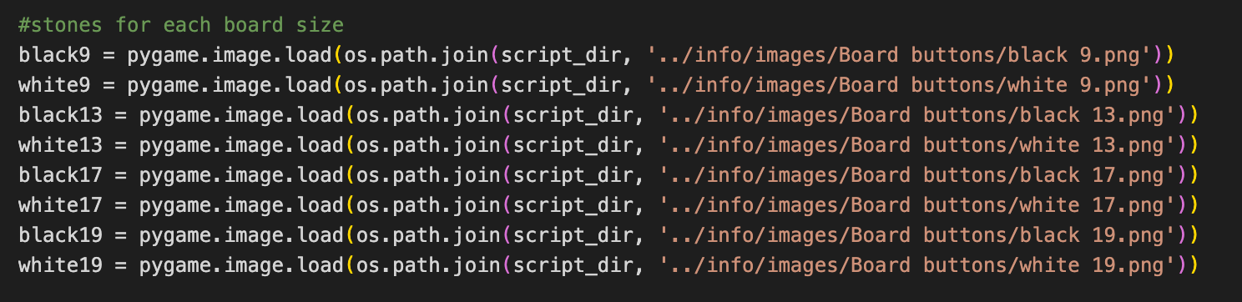

##### BUTTON IMAGE

Here is the button I will be using to allow the users to place a stone on the board. There must be a button for each viable position. This is because is pygame you cannot have one image, the board, act as multiple independent buttons unless you specify the exact coordinates of each button on the screen.

This method would have taken too long to implement and would be very imprecise as I would have to continually check the size of the space that runs the button which would cause problem for the user as they might press in the correct area but might be oe pixel off, thus not presenting the stone. This is very frustrating for the user. To overcome these issues, I have used an image to carry out the function of placing a stone on the board. Here I am loading its image.

I must load it using the python os module as loading it with the more flexible pygame library would cause issues with my button class I have created



##### HOLDING INFORMATION FOR EACH BOARD

To be able to make the program run any size board as wished by the user, I will use a library that holds all the information of each board with the key being the board size. So I can access all the board specific information for each board from this dictionary using just the size of the board as a requirement. The size of the board is acting as the key in this dictionary, and all of the information will be stored in an array.

To position the stones on the board I have used the position coordinates for the buttons of the board to allow me to easily place them on screen. Doing this showed that the stones were not places exactly on top of the button, so to fix this I have added an offset for each black and white stone on the board. I add this offset to the respective position button coordinates to allow me to place the stone directly above the button.

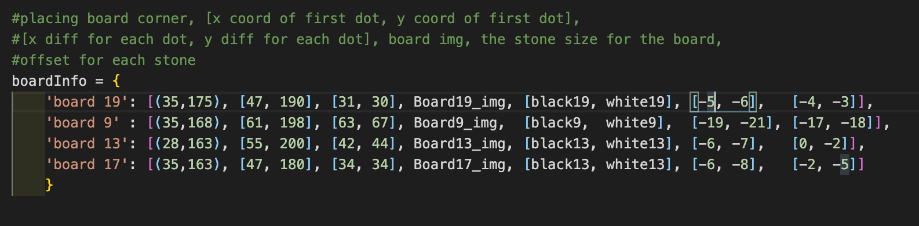

For each board I have stored:

1. Where the board should be placed on screen
2. The x and y coordinate for the top left corner position button
3. The x and y space between each position button on the board
4. The board image
5. The black and white stone image
6. The offset for balck stone
7. The offset for white stone

#### Main loop page generating function

##### Board processing before running the window

###### Global Variables

I make the variables ifMoved and ifSafe global so I can access and edit them when creating the window.

###### Creating the window

I created the window, giving it the correct dimensions and named the window ‘board’

###### Fetching the chosen game size

I fetch the inputted window size the user has chosen in the new game window from a json file ‘newSize.json’ and save it as size

Then using this I create the boardSize variable, concatenating the size with ‘board ‘ as then I can access the board specific information from the dictionary.

###### Information for each position on board

There are 2d arrays that will hold what is currently being held on each position on the board (black stone, white stone, captured, free), holding each button with respect to its position on the screen, and the coordinates of each button.

The coordinates of each button will be needed as I use this to let me know where to position the stones for each board easily and quickly

###### Creating the buttons

I create the buttons for each position on the board by looping through each cell in the 2d array, boardButtons. I created the board buttons using the buttons class I have created. I calculate their coordinates by using the startX and startY from the boardInfo dictionary and add on the button difference which I call from the boardInfo dictionary.

###### Creating variables to hold usernames

I have used name1 and name2 to hold the user names of the players and used the pygame font function to put them into comic sans, letting me put them on screen

###### The code for this

##### RUNNING THE WINDOW GENERATING WHILE LOOP

Here is where the window will regenerate continually updating the page with relevant information

###### Blitsing the images on screen

Here I place the background, bluebar and name boxes on screen. I also fetch the inputted icons selected by the user and the names the users inputted previously

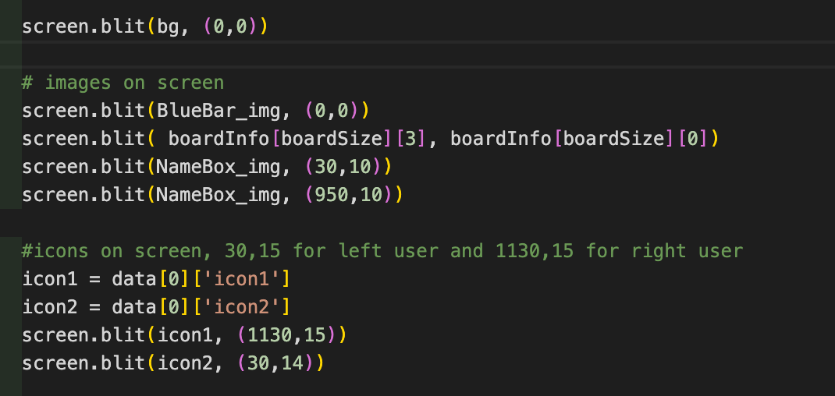

###### Blitsing the buttons on screen

Here I place all the buttons on to the screen, them being fetched from the ButtonArr

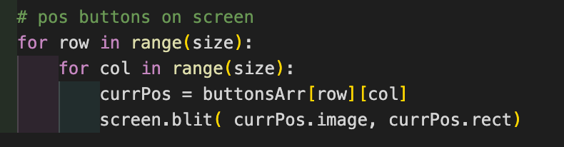

###### Checking for captures after moves

Here I check if a stone has been captured, if so It should be removed. This initially checks if the ifMove variable is true, if so it continues the check. I do this so the program doesn’t call the recursive code every time the window regenerates as this would mean the computer would have to do a lot of unneccesary load which would annoy the user as it might over heat the cpu and cause the fans to be very loud while playing the game. This saves doing extra computational work.

After the checks, I make sure we are checking a position that is being occupied by a stone, as those are the only relevant positions when checking if a stone has been captured, so removing it.

I then create a temp deep copy of the board. This allows us to run the checkCaptured function on the temp board while not affecting original board. This is good as it will still present the correct board to the users.

Before running the checkCaptured function, I set ifSafe to false, so when the code runs, it will output the correct value of ifSafe allowing us to know if the current stone is safe or not. If it is not safe we change the position to -1 letting the rest of the program know that this spot is unavailable to play in and so it also abides by the other rules of go.

After all of this we set ifSafe back to false so it can be correct the next time this code runs

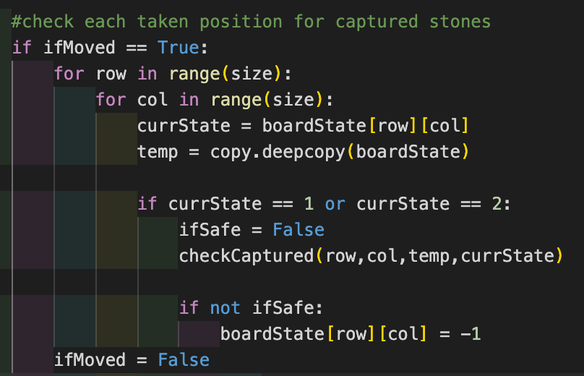

###### Blitsing the stones on screen

Here I place the black/white stones on screen. I achieve this by getting the respective stones for the board from the boardInfo dictionary. Then looping through the whole board, getting the positions of each button, the offsets for each stone and then checking if the current position from the boardState array is either 1 or 2, if so we place a black or white stone on screen respectively.

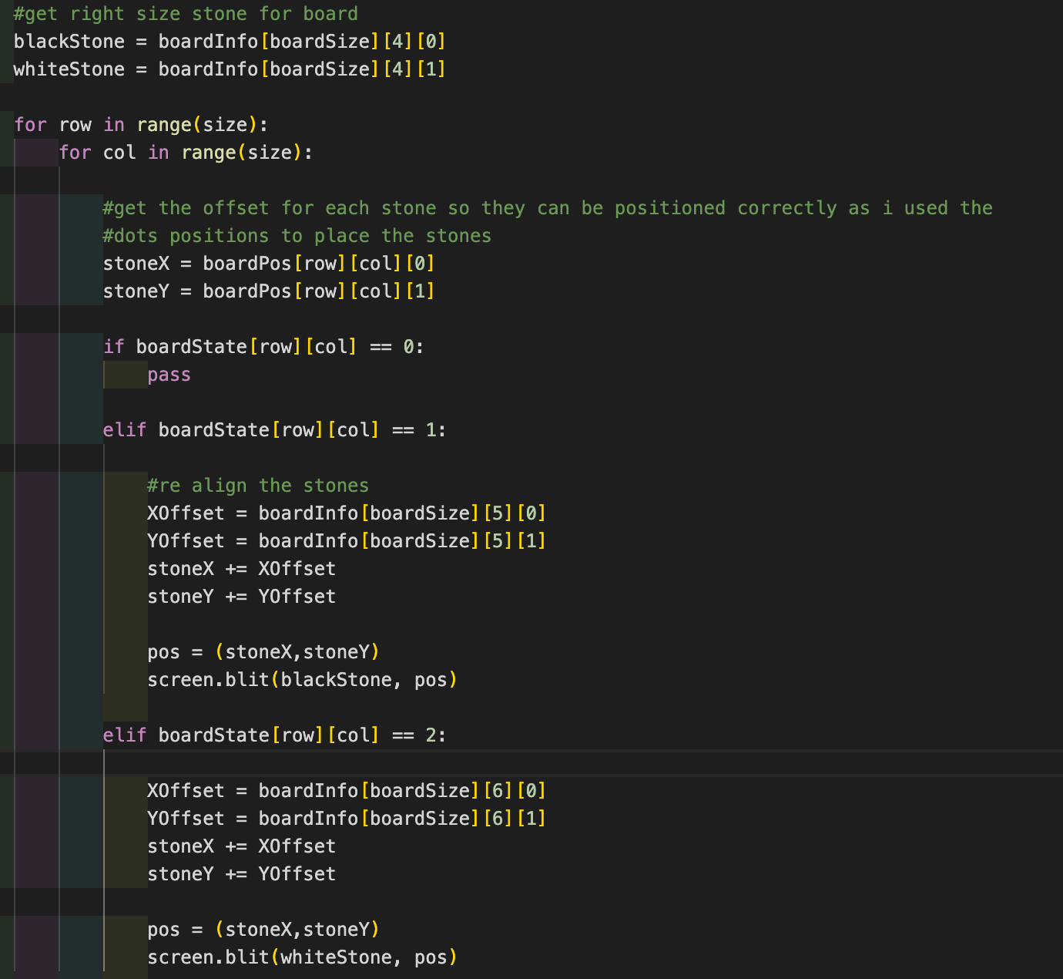

###### Event handling

At the end of the loop, I do pygame event handling loop, this is to check if a position button has been pressed or not and then refresh the page

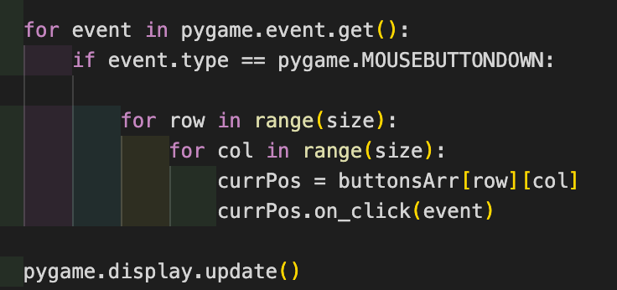

#### Setting up the server

When creating the server I will use a set number of ports, 20 ports, which I will then loop through the 20 ports and every time I use a port for a game I will set it as used. When a new player tries to start a new game it will look through the currently un used ports and choose a new port through a round robin approach looping through each one. When they leave the port will be exited properly and will now be unused, so therefore other users can now use the free port if they wish. This will allow me to let more than one pair of users